Wow Science
Alka-Seltzer rockets, straw oboes, clucking cups and homemade tornados - you would be amazed what you can do with everyday ingredients and just a little pinch of science.

‘Wow Science’ is a fast-paced, highly interactive hot-pot of entertaining and educational science-related demonstrations. The workshop takes on an interactive format, with participants encouraged to try out the demonstrations for themselves and explore the science behind how they work. With so much to learn and a whole lot of fun, one thing is for sure: the audience will be wowed by science as a result.

‘Wow Science’ is best suited for KS2 and lower KS3 audiences, although it is also applicable to family groups. Up to 30 participants can be accommodated at one time, with each workshop lasting between 30 minutes and one hour.

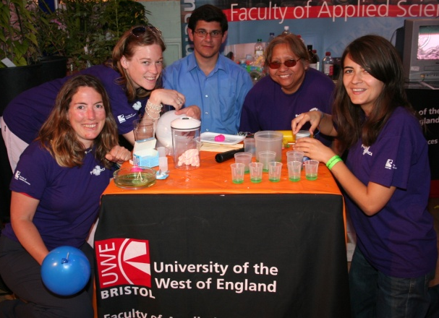
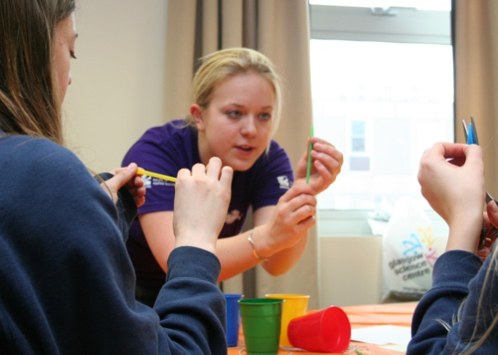
The Presenters
Current UWE students have been trained to run the ‘Wow Science’ workshops. They will assist the participants to perform the demonstrations and will also facilitate discussions about the science involved.
The ‘Student Science Communicators’ (or SSCs as the presenters are called within UWE) are recruited from a range of scientific disciplines including forensic, environmental and biomedical sciences as well as psychology. The SSCs are also happy to talk about the experience of going to University as well as the courses they study. If you are interested in hearing from SSCs with particular subject specialities please make this clear within the booking checklist overleaf.
All the SSCs have been CRB checked and are fully trained in the health and safety aspects relating to each of the demonstrations being used. They will bring all necessary equipment apart from that noted overleaf in the booking checklist.
Wow Science
Venue Checklist

Please return this checklist at least two weeks prior to our visit to your venue. It should be emailed directly to the Faculty of Health and Life Sciences Marketing and Events Assistant, Justin Iriajen (details below). If you have any queries about any of the requests please contact Justin well in advance of the workshop(s). Failure to do so could result in delays or possible cancellation of the visit.

Email: Justin2.Iriajen@uwe.ac.uk Telephone: 0117 32 83285

Venue Details
Please confirm your venue details to ensure that we have the most up-to-date information.
Venue Location
Full Venue Address

Contact Person
Full Contact Details (please include a mobile or 24-hour number for emergencies)
Email
Phone
Fax
Mobile/24-hour

Performance date
Workshop time(s) 1st workshop
2nd workshop
3rd workshop
4th workshop
Instructions upon arrival
(e.g. where to sign in, where to park, what times the venue will be accessible, plus any other information about the venue that may be helpful).
Audience Details
Please note that up to an hour may be required either side of the workshop to setup and pack up.
Please complete as fully as possible for each workshop so that we can plan the workshops to best suit the expected audiences. Note that ‘Wow Science’ is best suited to KS2 and lower KS3, with up to 30 participants able to be accommodated in each workshop.
 | Workshop1 | Workshop2 | Workshop3 | Workshop4 | Workshop5 | Workshop6
Duration of workshop
Total audience #
# Teachers present
# Year 3 students
# Year 4 students
# Year 5 students
# Year 6 students
# Year 7 students
# Year 8 students
# Year 9 students
# other attendees
(please specify)

Please indicate if students / learners from any of the following backgrounds will be present:

Low HE participation neighbourhood
Lower socio-economic group
Deprived geographical area
Little or no HE in family
Minority ethnic groups
Disabled

If there are any other external organisations involved in this visit (e.g. feeder primary schools) please list such organisations here, including the number of participants from each organisation:
List all organisations involved in this event | Number of Participants

Item Checklist
Please indicate (by selecting the relevant boxes) which items you will be able to supply at the venue. Please have these items ready well in advance of the first workshop.
Requirements:
Item Required | Number | Supplied?
Large table(s) | 4
Large bin (for disposal of rubbish after the workshops) | 1
Nearby access to water e.g. a tap before the workshop | 1
Facility to turn off smoke detectors in the venue* | N/A

* There are some demonstrations performed by the SSCs which produce small amounts of smoke. If your venue has particularly sensitive smoke detectors we advise that they are turned off for the duration of the workshop. If this is not possible then please let us know in advance so that those demonstrations can be avoided.

Additional Information
Is there any further information that the SSCs should be aware of, for example topic areas recently covered in class or subjects you would particularly like the SSC’s to focus on? Please use the space below to provide any additional information you think would assist our visit.

Full details of the demonstrations performed by the SSC’s, including a full risk assessment, are available for download from: http://www.scu.uwe.ac.uk/index.php?q=node/80.

We look forward to visiting you!

UWE SSC team

