PGR Partnership Studentship Opportunities
Partnership (co-funded) PhD studentships for starts in 2020/21 are available for applications. This is an open, ongoing call for applications. If academics can find partners who can fund as below, they should use the attached application form and we will endeavour to respond within three weeks. We are envisaging that PGRs will start on 1st Oct 2020, though earlier starts may be possible.

Introduction
UWE is aiming to increase PGR numbers, in part through working more closely with its partners to deliver a high quality postgraduate research experience. A central pot of funds is, therefore, now available to support Partnership (co-funded) PhD studentships, starting during 2020/2021.

Partnership Process
2.1 We are looking to complement UWE financial input with that of external partners in order to fund, on a cash cost basis, PhD studentships. The total cash costs of a PhD are about £69k in total (23k p.a. FT). In addition to carrying the remainder of the full economic costs (which can be £100k or more), UWE will contribute between 80% and 25% of the cash costs, with partners funding the remainder, i.e. between about £4k and £15k p.a. (about £13k to £50k in total (see table overleaf). We envisage that the percentage of the costs covered by the external organisation will be appropriate to its financial strength and to the degree of benefit likely to accrue to it and to UWE as a result of the project - from some types of funders we will ordinarily expect more than 50% of cash costs, whereas for others <50% may be appropriate.
  - We are happy to position the partnership as the partners funding the stipend or part thereof. We can label payments to the student the ‘[partners name] stipend’. Partners’ financial contributions will still need to be paid to UWE so we can then pay a tax-exempt stipend to them as a PGR student, but partners might like to think of their money directly supporting students.
  - There is, at present, no cap on the total number of studentships offered or that can be applied for from any faculty. We do, however, particularly welcome applications from ACE and FBL because are looking to work with partners appropriate to the full range of UWE’s Research Beacons. .
  - Given that there are no caps on numbers of studentships at present, and with the caveat that all proposals will have to approved as suitable for PGR study at UWE, academics may apply for up to 50% of the costs of a single studentship to be ring fenced for up to 6 months in order aid approaches to potential partners.
2.5 UWE’s PGR regulations on the format of the final PhD thesis now allow for outputs that might be useful to partner organisations to be submitted as part of the final thesis - so it is possible that PGRs might produce a variety of outputs of direct utility to partners and incorporate them into ‘the body of work’ submitted for PhD. See PGR Reg. 13.10.1 and 13.12.
2.6. Academics and partners might like to consider the role of doctoral loans in funding a studentship. If partners can contribute relatively limited amounts, it is possible to advertise partnership PhD opportunities that offer part funding suitable for a candidate prepared to take out a doctoral loan.
2.7 As UWE is putting money into the scheme and paying the non-cash costs all studentships will have to be advertised in open competition.
2.8. You need to get Faculty approval (Assoc Dean RKE or delegated authority) as part of the application and, if successful, put it on PASS and get contracts drawn up before it can be advertised.

2.9 Partnership PhD students will have access to the full range of UWE skills development, support and facilities. This includes a wide-ranging programme of skills development workshops for PGRs, all UWE’s library facilities, all student facilities on campus including some dedicated PGR spaces, and access to UWE Health & Wellbeing Services, Accommodation Services, and Financial Advice Centre and all UWE Student Union activities and facilities.

Eligibility
  - Applications must be submitted by a member of UWE academic staff who is qualified to be a Director of Studies. In each academic year applicants will be awarded no more than two ‘partnership PhDs’ as DoS and no more than three partnership PhDs as a supervisor in total.
  - The external partner can be any type of non-academic organisation (private, public, third sector), based in the UK or overseas.
  - Partnership Studentships are normally available on a full-time basis but part-time will be considered if appropriate and agreed by the co-sponsor. The budget for a part-time award should be the same but spread over six years.
  - Partnership Studentships are not appropriate for professional doctorates, DPhils or MPhils.
  - International students can be recruited provided the Faculty or external partner is willing to support the additional costs required to cover international fees.

Application process
  - Applications should be made by a UWE academic on the form attached with the confirmed commitment of an external partner. Applications can be made at any time although start dates must fit with the existing timetable that allows students to start on 1 October, 1st January, 1st April.
  - Applications will be considered by a panel of the Graduate School Committee, reporting to the University Research & Knowledge Exchange Committee. The panel will comprise the four Chairs of Faculty Research Degree Committees, or their nominees, and be chaired by the Graduate School Director. Input or expertise may be accessed from other sources as necessary.

Assessment
  - Applications will be assessed for their eligibility for the scheme and for their suitability as the basis of doctoral study. They will also be assessed against the University’s strategic themes and research priorities (see below).
  - Priority will be given to collaborations with new external partners, and to staff who have not previously benefitted from schemes deigned to support collaborative research. Staff seeking to establish such collaborations can access support from RBI.

Recruitment
  - Any studentship opportunity should be advertised openly and recruitment must be through the usual UWE PGR recruitment process. The external sponsor should be represented on the interview panel.
  - The recruitment process may be initiated once the application has been approved by the panel, but a project cannot start until a partnership agreement with the co-sponsor is signed.

For further information or guidance please contact:
Vicky Nash, Graduate School Manager, victoria.nash@uwe.ac.uk

Partnership PhDs – Financial Table

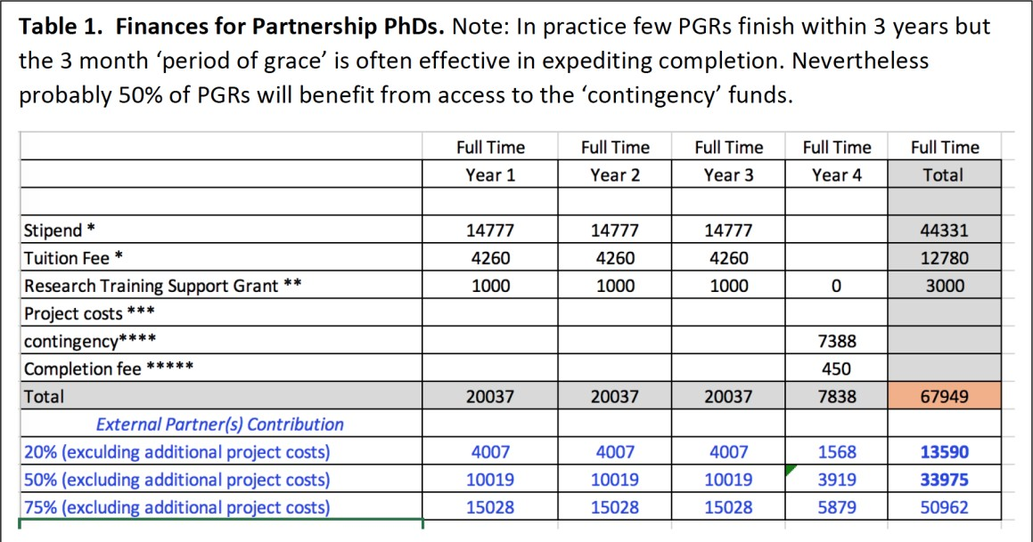

* these will increase annually in line with UKRI rates
** The RTSG is for conference attendance, specific training, travel etc..
*** Project costs are the direct costs of carrying out the research, including consumables, items of equipment, IT etc…
**** this is to be used if the student requires, for example, fees funding after 3y or PT equivalent, has a period of parental leave, etc.
***** After 3 years or PT equivalent there is a 3-month period of grace from fees but this completion fee is still payable.

UWE’s Research Beacons
