Worksheet for Labelling River Landforms Activity for Key Stage 3
There are three different sections of a river, these are known as courses; the upper course, the middle course and the lower course.
Please follow the journey of the river, completing the activities along the way to label different landforms.
To complete this activity, you will need:
- Access to the internet to watch the video and share your work once completed
- A print-out of this worksheet, plus a pen or pencil
Once you have completed this worksheet please send it to cu@uwe.ac.uk for your Stamp Code. This activity is worth one credit and should take you one hour to complete.
The upper course:
In the upper course you will often find waterfalls. Can you label the different parts of a waterfall below?
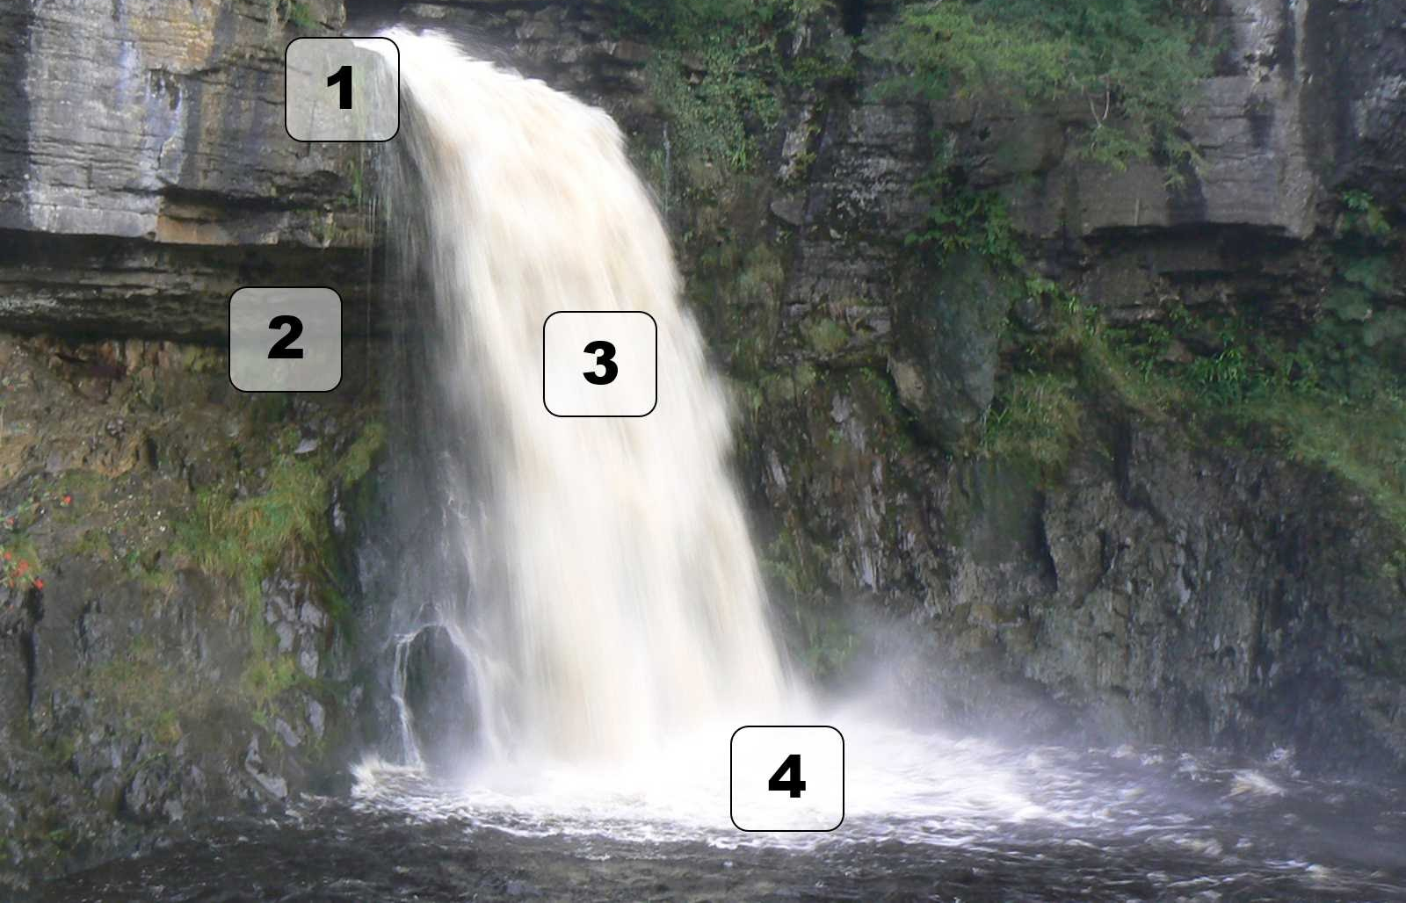
Image from GCSE Geography, undated.
The middle course:
Please watch this video. https://www.youtube.com/watch?v=izgc3vFimP8 and think about how the surface of the land changes over time as the river moves around. The video shows part of the Ucayali River in Peru. This is the middle course.
On the image below, label the two yellow boxes highlighted, choosing from the following options:

- River course
- Meander bar
- Oxbow lake
- Floodplain
- Mid-channel bar

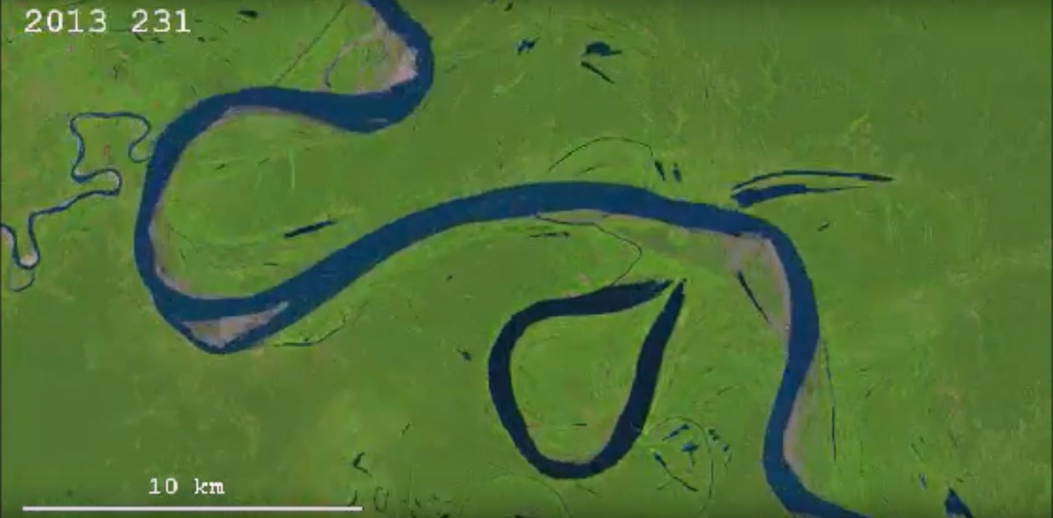
The lower course
The picture below shows the lower course of a river. Label the following parts on the picture:
- Braiding
- Flat land
- Delta
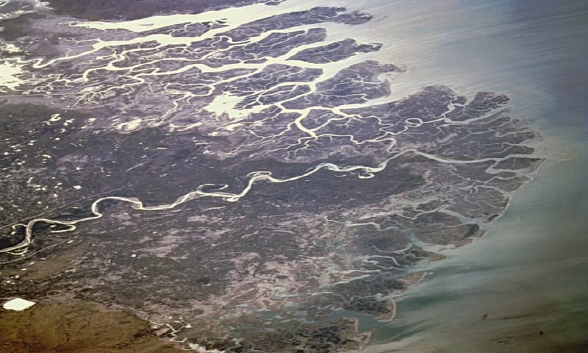
Well done on completing this task. Remember to email cu@uwe.ac.uk to get your Stamp Code.

