UG3B 2022 - 23
Information for schools and trainees
27th February 2023 – 26th May 2023
Professional Practice Handbook

Primary Undergraduate Year 3

Contents

- Aims of the Handbook page 3
- Key Contacts page 3
- Placement Documentation page 4
- Module Information page 4
- Module Enhancement page 4
- UG3B Block Placement Details page 7
- Procedures for UG3B Block Placement page 8
- UWE Tutors page 11
- Illness and Covid-19 Guidelines and Protocols page 12
- Placement Dates page 12
- UG3B Professional Placement log page 13
- Weekly Overview & Expectations page 14
- Mentor Support page 18
- Evidence page 19
- Teaching Files / Evidence Portfolios page 20

Appendix 1 UWE Progress Matrix
Appendix 2 Teachers’ Standards
Appendix 3 UG3 Year Curriculum

Aims of the Handbook
This handbook is a guide for trainees in the Department of Education and Childhood and mentors in our partnership schools. The information in the handbook can also be found in a number of other electronic or paper sources and the document provides links to the definitive data sources wherever possible.

Please note that the electronic version of the handbook will be kept up to date and you will be notified of any significant changes. If you have taken a hard copy of any information please remember to refer back to the electronic version to ensure that you are working with the most up to date information.

This document contains information which is specific to Undergraduate 3rd Year Trainees – Block B Placement.

The document is intended to support both trainees and placement schools and should be read by both prior to the commencement of the placement and then referred back to throughout the trainee’s time in school.

Key Contacts
Name | Position | Contact
Alistair Law | Primary Phase Partnership Manager | 0117 328 1802 alistair.law@uwe.ac.uk
Amanda Wilkinson | UG3 Year Leader | 0117 328 4947 Amanda3.wilkinson@uwe.ac.uk
Karan Vickers-Hulse  Julie Buckland | Associate Heads of Department for ITE | 0117 328 4137 karan.vickers-hulse@uwe.ac.uk  0117 328 7112 julie2.buckland@uwe.ac.uk
Professional Practice Office | Primary Partnership | 0117 328 4143 partnership@uwe.ac.uk

Placement Documentation
All placement documents can be accessed via the following link to our website: go.uwe.ac.uk/rvcnr or https://go.uwe.ac.uk/ovybm

The UWE Training and Assessment documents will be accessible via the links above and shared with trainees.

Module team information

Many expert colleagues contribute to this module curriculum, not just those working at UWE, including Senior Mentors and Class Mentors in schools. Other colleagues from partner schools may input specialist knowledge to the learning, for example Special Educational Needs Coordinators, Senior Leadership Team members, Safeguarding Leads, and Pastoral Leaders.

External examiners from other institutions are appointed to each module to act independently and work with the module team in the management of threshold academic standards. Information is available about the external examiner appointed to this module.

Module enhancement
We are a flexible and reflexive programme and work hard to respond to the feedback of our trainees. If you have any innovative suggestions as to how the module might be improved for future cohorts, please do let us know!

The Professional Practice modules, otherwise referred to as your ‘school placements’ are, quite obviously, a critical component of the vocational programme experience. We are constantly seeking to enhance this provision, through mentor training, close partnership communication, and steering groups of key stakeholders. Most recently, for example, the lesson observation and planning pro formas were redeveloped as a result of these consultations to better meet the needs of ITE trainee teachers. We consulted with partners regarding changes to assessment and the platforms used for recording evidence.

Aims and Distinctive Features

Professional Practice modules constitute a large proportion of your time studying on our undergraduate programme, and are the location of much learning. This learning is guided by expert input, experience, reflection and independent study – and is complimented by the centre-based sessions you encounter too. On Professional Practice, it is particularly important to us that you have the opportunity to ‘learn how to…’ employ or operationalise the knowledge that you have gained while centre-based to positively impact on the progress of your pupils.

The five aims of this module are stated as follows:

- Develop trainees’ ability to demonstrate and evaluate effective, evidence-based, practices in learning and teaching to support all learners to make good progress.
- Support trainees to apply their knowledge and understanding of key subject-focused concepts, curriculum and pedagogical approaches, and to be able to evaluate and plan for learners’ needs and successes.
- Provide trainees with opportunities to develop their understanding of child/adolescent development, diverse needs, and the contexts of learners’ lives, to learners’ social, cultural, emotional and academic development.
- Support trainees to develop effective communication skills and the ability to build respectful, positive, relationships with children and adults.
- Develop trainees’ understanding of the professional responsibilities of teachers and support them to apply appropriate professional skills, understandings and behaviours, identifying their ongoing professional needs.

Curriculum

All of the ITE programmes at UWE are conceptually organised in three progressive phases – first, we expect you to engage with aspects of education, then build confidence embedding these in your own practice, before considering how to enhance the experience of your pupils. The 3rd year Professional Practice module A allowed you to embed skills developed in previous years with the profession and build confidence and competency quickly, while Professional Practice B then asks you to enhance this learning as you develop, and latterly secure the skills to be a successful early career teacher.

While centre-based, a series of module sessions provide both statutory and professional content to ensure you are prepared to meet the standards of practice expected within the typical primary school. For these sessions there is not necessarily a standard delivery format – some may include lecture and seminar input while others may be external and independent in nature.

Professional Practice content should be delivered by mentors during practice-based aspects of the UG programme too. These sessions are an invaluable way to learn from expert colleagues about how professional teaching and effective learning take place in the specific context of your school placements. These sessions are sometimes labelled as Professional Development, or similar and are positioned to facilitate exactly that. They are not necessarily delivered in the form of staff meetings or individualised sessions but could be conversations or discussions about particular areas. UWE PD Sessions resources document itself is a guide to how to access resources to support your placement whilst in school.

You might note that all the sessions listed in the Professional Development document have been mapped to our UWE Transformational Teacher Framework (TTF). The Professional Practice module has been formulated to comprehensively cover the core concerns of classroom teaching in an English primary school. As such, sessions will focus acutely on six areas of the TTF: Pedagogy, and how young people learn, Behaviour Management and Assessment, or how you might teach, Curriculum, Professional Behaviours, and SEND understanding. While much of what we do inter-relates a number of descriptors, the righthand column is colour-coded to suggest the primary link, following the key below:

Assessment | Autonomy | Behaviour Management | Context | Evidence-led Criticality | Curriculum | Equity | Expertise | Pedagogy | Professional Behaviours | SEND

UG3B Block Placement Details
Trainee’s name/trainee number:
DBS Number:
Name of school:
Class/year group:
School email address:
School address:
Headteacher:
Class mentor name:
Class mentor contact details:
Senior mentor name:
Senior mentor contact details:
UWE tutor name:
UWE tutor contact details:
Safeguarding lead:
Date of safeguarding training:
Date of PREVENT training:

- Procedures for UG3B Block Placement
The UWE Department of Education & Childhood partnership portal and the resource portal contains documents relating to the following procedures.

- Before the start of the block practice the trainee should complete page 7 in this booklet and page 13.
- UG3B for 2022/23 is 11 weeks long and trainees will attend full time, Monday to Friday. Trainees should settle back into class routines and begin teaching within the first week.
- At the end of each placement week the trainee should record the days completed in school this week on the chart on page 13 and this should also be signed off in the final column of the chart by the mentor or senior mentor. This is also replicated within the trainee’s online SWEPT workbook. It is the trainee’s responsibility to ensure that this record is kept up to date as it will provide evidence of the trainee’s completed days in school.
- Each week, during block placement, the trainee will engage in a series of activities and reflections:
- Engage with a schedule for observation of teaching and learning, as directed by the mentor. Record and reflect observations of the mentor teaching on UWE proformas.
- Support the mentor to create resources for lessons and displays. Reflect on the efficacy of these to support teaching and learning.
- Mark pupils’ work alongside the mentor, according to the school’s marking policy, with increasing independence. Reflect on the use of marking (formative assessment) to inform subsequent planning.
- Under direction of the mentor, engage in a graduated schedule of whole-class teaching, towards 80% after Easter.
- Collate weekly class timetables for observations, participation and direct teaching in order to track increasing workload.
- Reflect upon all teaching strategies, interactions, and assessment using the 2022-23 UWE Lesson Plan form. On discussion with your mentor and UWE Tutor, this may be relaxed after the Easter break.
- Work alongside the teacher in creation and resourcing of medium-term units of work relating to the school’s intended curriculum.
- Reflect upon a weekly formal lesson observation feedback, provided by the mentor.
- Reflect upon informal lesson observation feedback, provided by the mentor.
- Reflect upon examples of pupils’ classwork where teaching has had an impact on the quality of pupils’ learning.
- In consultation with the mentor, the trainee will undertake complementary training. This may include focused discussions and interviews with subject/assessment/pastoral leads; observations of other teaching staff; review of subject knowledge resources, etc..
- All lessons taught by the trainee must be planned using the UWE Lesson Plan. These are to be kept by the trainee on file.

- Weekly Review Form (completed in SWEPT)
On this UWE form, the trainee will review progress made against SMART targets for teaching, learning and assessment and set new targets for the following week. These will be monitored by the UWE tutor and should be completed every week in a timely manner as a priority.
- The trainee will ‘map’ each new set of SMART targets against the UWE Progress Matrix.
- The trainee will reference a wide variety of evidence to substantiate both review and target setting, as described above.
- The trainee will complete a personal reflection on their professional development on the placement to date. We have produced a separate UWE PD Sessions document. Use this to signpost trainees to support areas in which they need to improve. PD sessions do not have to be full sit-down sessions. They can be directed work, anecdotal discussions or formal discussions with members of staff.
- Should the trainee have any concerns about their workload or progress, it is essential they discuss with their class mentor and/or UWE tutor ASAP. There is a mechanism to do this through the SWEPT workbook or directly via email.
Weekly formal observations of teaching will be recorded on a shared Lesson Observation, Feedback and Reflection Document by the mentor, and added to by the trainee.

- On a daily basis, during block placement, the mentor will provide ongoing guidance, support and graduated challenge for each of the trainee activities detailed above, so that the trainee can develop their expertise towards the Teachers’ Standards through the UWE Progress Matrix. This professional dialogue will include supporting the trainee to manage their increasing workload and to develop positive relationships with colleagues, pupils and the school community.

- Each fortnight, in a scheduled fortnightly meeting:
- The classroom mentor will record details of the meeting through the trainees’s SWEPT workbook.
- The classroom mentor will summarise the evidence presented by the trainee to support progress against the UWE Progress Matrix. At the end of the 2nd week (and subsequently after every 2 weeks), the mentor will compete a fortnightly review of the trainee’s progress. This is a short summary of the preceding two weeks. It is devised within a formal meeting between the mentor and trainee.
- The classroom mentor will make an evaluative YES/NO judgement on progress through the UWE Progress Matrix.
- If the trainee is judged to be making unsatisfactory progress after a period of warning, a ‘Professional Improvement Plan’ procedure will be requested by the classroom / senior mentor for the subsequent 2-week period. This will always be discussed and written in conjunction with the UWE Tutor before implementation.
- Professional Improvement Plan leading to Cause of Concern: Should the trainee’s progress be judged to be insufficient following the 2-week PiP review, a CfC will be initiated by the mentor/UWE tutor for the subsequent 2 weeks.
- At the end of the CfC 2-week review, if the trainee’s progress is again judged to be insufficient, the trainee will be at risk of a failed placement.

- At the end of UG3B, there will be a final placement report completed by the mentor, and a Viva with the UWE Tutor conducted at UWE (focused discussion giving the opportunity to present justifications for achieving the Teacher Standards) for the trainees to complete to demonstrate their understanding.

UWE Tutor contact /visits and reports - key dates and information at a glance
All trainees have been assigned a UWE Tutor who will be their primary contact at UWE. Our highly experienced UWE Tutors will remain in active contact with schools and trainees throughout the placement, in response to any questions or concerns held by the trainee or mentor. Communication from UWE Tutors should be responded to in a timely manner.

Event | Date | Actions | Other notes
The UWE tutor will make contact with the mentor and trainee. | Ongoing | Queries or concerns communicated to Primary Partnership Manager: alistair.law@uwe.ac.uk | UWE Tutors will remain in active contact with schools and trainees throughout the placement, in response to any questions or concerns held by the trainee or mentor.
UWE Tutor visit 1 | Between  20th Mar – 31st Mar  (weeks 4&5 of block placement) | The designated UWE tutor will make arrangements with the mentor to undertake a visit to support a successful placement. This will occur The first face to face visit will be in weeks 4-5 of UG3B (20th Mar – 31st Mar). This visit is a vital opportunity to quality assure the trainee’s response to mentoring. The UWE tutor will observe a lesson in this visit. In this visit, the UWE tutor will facilitate a professional dialogue between the mentor and trainee, where formal lesson feedback is provided and future actions are agreed. | These visits are intended to support the trainee and the mentor, and moderate evaluative review of the trainees’ progress.
UWE Tutor visit 2 | Between  15th May – 26th May  (last two weeks of placement) | The designated UWE tutor will make arrangements with the mentor to undertake a second face to face visit to support a successful placement. This will occur at the end of your block placement in weeks 10-11 (15th May – 26th May), unless required sooner than that. This visit is a vital opportunity to quality assure the trainee’s response to mentoring, their teaching ability, and the progress towards meeting the Teacher Standards required for Qualified Teacher Status. In this visit, the UWE tutor will observe part of a lesson, have a discussion with the mentor and trainee.

Illness and Covid-19 Guidelines and Protocols:
Trainees will be expected to follow guidelines and protocols as prescribed by individual schools attended during placement. These specific guidelines may differ from other settings and those set out by UWE.
In the case of absence
If absent from school, trainees are required to contact the school each day of the absence, in line with school policy. They must then email ITEAbsences@uwe.ac.uk copying in Alistair.Law@uwe.ac.uk, and their UWE Tutor as well.

Trainees should also contact this office if they display symptoms of / test positive for Covid 19.

IT IS IMPERATIVE THAT BOTH SCHOOLS AND UWE KNOW IF YOU ARE NOT IN SCHOOL.

- UG3B Placement Dates 2022-23
In the case of absence
If absent from school, trainees are required to contact the school each day of the absence, in line with school policy. They must then email ITEAbsences@uwe.ac.uk copying in Alistair.Law@uwe.ac.uk and their UWE Tutor as well.

Trainees should also contact this office if they display symptoms of / test positive for Covid 19.

IT IS IMPERATIVE THAT BOTH SCHOOLS AND UWE KNOW IF YOU ARE NOT IN SCHOOL.

- UG3B Professional Placement log
This should be a duplicate of the log completed during UG3A. Each of the following should be addressed before or during the serial days by the trainee in consultation with the Mentor / Senior Mentor / UWE Tutor. Trainees should initial and date when complete.
Before block school experience | Initial & date
The trainee has contacted the school, introduced themselves and sent their pen portrait.
The trainee has located end of UG2 report and has targets in mind.
The trainee has ensured that the school has received their DBS number.
The trainee has received a copy of the school’s induction guidance for trainees (if available).
The trainee is receiving ongoing guidance in terms of the school’s COVID 19 risk assessment and procedures (if applicable).
The senior mentor and/or mentor has attended UWE mentor training
The trainee has read the school’s Child Protection Policy and has had Child Protection training in school.
The trainee is aware of and has met with the members of staff with key roles in the school e.g.: safeguarding lead, child protection lead.
The trainee has a copy of Keeping Children Safe in Education
The trainee knows the Health and Safety policy and practices for their school e.g.: fire drill, sick child etc.
The trainee knows and understands key school policies such as behavior management, marking and assessment and is demonstrating knowledge of these.
The trainee has an agreed timetable for their and teaching responsibilities which is reviewed each week.
The trainee is using an appropriate format for lesson planning and assessment, recording and reporting.
Attendance at staff meetings, training days, parents’ evenings and other professional training events have been shared and agreed as appropriate.
The trainee has had a professional discussion with their mentor about the progress of children in their home class.
The trainee is aware of the school’s staff behaviour policy (sometimes referred to as a code of conduct).
The trainee has shared their targets and Inter-Placement Profile from UG3A with their mentor to support future planning for progression.
During block placement:
The mentor understands that they have a professional responsibility to formally observe the trainee every week (Wks 1-11).
During block placement:
The mentor understands that they have a professional responsibility to formally meet with the trainee each fortnight to review targets and progress (pupils’ and trainee’s) and set new targets for the following week.
During block placement:
The mentor understands that they have a professional responsibility to provide ongoing guidance, support and feedback through planning and assessment meetings, both formal and informal.
During block placement:
The school (class mentor or senior mentor) should conduct weekly professional development session with the trainee.

- Weekly Overview & Teaching Expectation

Placement Week |  | Week 1 | Week 2 | Week 3 | Week 4 | Week 5 | Week 6 | Week 7 | Week 8 | Week 9 | Week 10 |  | Week 11
English and Maths |  | increasing the number of lessons to a sequence of three in a week |  |  |  |  | increasing the number of lessons to a sequence of five in a week
Science |  |  | One lesson |  |  |  | A sequence of three lessons
Foundation | Design & Technology |  | A sequence of two lessons from any three of these subjects |  |  |  | A sequence of at least two lessons from the remaining subjects
 | History
 | Geography
 | Art & Design
 | Music
 | Physical Education
 | Computing
 | Religious Education
 | PSHE
 | MfL (KS2)
Please indicate which lessons you have taught and how many, week-by-week

English and Maths

Science

Foundation | Design & Technology
 | History
 | Geography
 | Art & Design
 | Music
 | Physical Education
 | Computing
 | Religious Education
 | PSHE
 | MfL (KS2)
Days Absent
CM or SM intitials
Week # | Trainee Responsibility | Trainee Teacher Focus | Mentor Observation / Support | Tasks to be completed (see Professional Practice Log)
Week 1 (33)  w/c 27th Feb | Observe mentor teacher  Assists mentor teacher and assists with small groups  20% teaching (rough guidance) (3-4 lessons this week) | Observe:  - Classroom management (rules, procedures, transitions, cues)  - Lesson planning and setting of objectives  - Strategies used by mentor  - Assessment & evaluation procedures  Teach:  Whole class lessons using own plans on UWE Lesson Plan Format  Plan individually and together with the mentor and be responsible for:  Classroom management  Prepared, written, effective implemented lesson plans for 3-4 lessons  Assessment, evaluation and grading for delivered lessons | Brief daily debrief, use trainee reflections to guide any discussion  Ask specific questions to determine trainee understanding  Weekly formal observation 1 | Introduction to school (if needed) ☐  Placement checklist (previous page) ☐  Weekly review 1 ☐
Week 2 (34)  w/c 6th Mar | Observe mentor teacher  Assists mentor teacher and assists with small groups  20% teaching (rough guidance) (3-4 lessons this week) | Teach:  Whole class lessons using own plans on UWE Lesson Plan Format  Plan individually and together with the mentor and be responsible for:  Classroom management  Prepared, written, effective implemented lesson plans for required %  Assessment, evaluation and grading for delivered lessons | Brief daily debrief, use trainee reflections to guide any discussion  Ask specific questions to determine trainee understanding  Weekly formal observation 2  Formal Fortnightly Meeting 1 (mentor completes Fortnightly Report 1) | Weekly review 2 ☐
Week 3 (35)  w/c 13th Mar | As above  40% teaching (rough guidance) | As above | As above  Weekly formal observation 3 | Weekly review 3 ☐
Week 4 (36)  w/c 20th Mar | As above  40% teaching | As above | As above  Weekly formal observation 4  Formal Fortnightly Meeting 2 (mentor completes Fortnightly Report 2) | Weekly review 4 ☐ | UWE Tutor Visit
Week 5 (37)  w/c 27th Mar | As above  60% teaching (rough guidance) | As above | As above  Weekly formal observation 5 | Weekly review 5 ☐
Week 6 (38)  w/c 17th Apr | As above  60% teaching | As above | As above  Weekly formal observation 6  Formal Fortnightly Meeting 3  (mentor completes Fortnightly Report 3) | Weekly review 6 ☐
Week 7 (41)  w/c 24th Apr | As above  80% teaching (rough guidance) | As above | As above  Weekly formal observation 7 | Weekly review 7 ☐
Week 8 (42)  w/c 2nd May | As above  80% teaching | As above | As above  Weekly formal observation 8  Formal Fortnightly Meeting 4 (mentor completes Fortnightly Report 4) | Weekly review 8 ☐
Week 9 (43)  w/c 8th May | As above  80% teaching (rough guidance) | As above | As above  Weekly formal observation 9 | Weekly review 9 ☐
Week 10 (44)  w/c 15th May | As above  80% teaching | As above | As above  Weekly formal observation 10  Final Placement Report | Weekly review 10 ☐ | UWE Tutor Visit
Week 11 (45)  w/c 22nd May | As above  80% teaching | As above | As above  Weekly formal observation 11  Final Placement Report | Weekly review 11 ☐
- Mentor Support
Once trainees are settled back into schools, they should start to teach some whole class sessions in the first week, with a bespoke schedule for how this will increase towards 80% of the week towards the end of the placement.

From the first week mentors will be expected to conduct a formal observation which is followed by a target setting discussion meeting (later in the week). The latter should be led by the trainee who is encouraged to be proactive in terms of taking responsibility for their training year.

Trainees are entitled to:

- be supported and cared for while simultaneously being sensitive to the needs of the pupils/students, school and mentor
- a supportive system of monitoring, through professional dialogue
- be allocated 10% for planning, preparation and assessment within school hours (best done with classroom mentor). They are also entitled to a further 10% time for complementary training – this time should be used for professional development / evidence collation / speaking to members of staff / or further preparation.
- regular meetings with the mentor for planning and assessment
Trainees perform best when:

- They feel valued.
- They have a professional buddy.
- They have a supportive and well-trained mentor.
(Vickers-Hulse 2021)
- receive guidance and support to devise weekly developmental targets
- be told if their performance is a cause for concern in good time, and be supported to address areas for development

The Role of the Senior Mentor

Most of your time in placement will be working with your Classroom Mentor, who will guide you through the placement, providing support needed for your progression. This is overseen by the Senior Mentor who is responsible for your overall progress and development when in practice and will be a part of your end of placement report. The Classroom & Senior Mentors will regularly meet with you at the Professional Development (PD) sessions they will set up and / or run. These sessions are essential to your development and will cover broad themes common to all subject specialisms such as SEND for example. It is likely that your Senior Mentor will formally observe you at least once during the practice placement.

- Evidence
Types of evidence to support progression (weekly reviews, fortnightly reviews, end of placement reports).

Evidence 1: Formal Lesson Observation, Feedback and Reflection form.
Evidence 2: Informal lesson observation feedback. These are your own notes. Keep a reflective journal.
Evidence 3: Examples of daily lesson planning & evaluation. Use the UWE Lesson Plan for ALL lessons (1:1, group and whole-class). Even if you are provided with planning from your mentor, transcribe and adapt it to this form. Be precise in you self-evaluation against the learning objective.
Evidence 4: Complementary Training Plan. This is a log of anything you do outside of teaching and assessing, in agreement with your mentor. Discuss with your mentor the few different activities you could undertake each week as part of your professional development. It may include:
- Observation of a lesson (guidance is available on the UWE resource documents portal).
- Consultation / Interview with a curriculum leader, e.g. maths, English, science, any foundation subject; SENDCo; Assessment Lead; Family Support
- Self-directed subject knowledge and relevant academic study (after school hours).
- Attendance at school training / INSET.
Evidence 5: Pupil/trainee classwork: photographed / photocopied examples of pupils’ work. Annotate this to unpick pupil’s barriers to understanding or application of skill
- Teaching Files / Evidence Portfolio
This evidence should be collated in an online OneDrive that can be shared with mentors / UWE Tutors as needed. Trainees may want to keep a personal paper file as well. The evidence from this OneDrive will be uploaded into the trainee’s online workbook.

Professional Teaching File

          - Clearly organized
The Teaching File is everything school-focused/facing
          - Weekly timetables
          - Daily planning and evaluation, medium and long term planning
          - Seating plans; differentiated groups
          - Key policies, e.g. Covid-19 risk assessment; behaviour management; safeguarding & child protection; marking

Professional Development Portfolio

          - Weekly review and target setting forms
          - Fortnightly mentor reviews
The Professional Development File is focused on trainees’ progress.
          - Formal lesson observation feedback and reflections
          - Informal lesson observation feedback and reflection (notes)
          - Photocopied sample of children’s classwork
          - Complementary training: e.g. observation of other teachers, consultations with subject leaders, school training
          - Subject knowledge audits
Appendix 1: UWE Progress Matrix
The UG3B placement is about enhancing practice sufficiently to meet the Teacher Standards by the end of the placement.
We would expect to see ≥50% of the areas of the UWE Matrix to be secure for a placement pass.
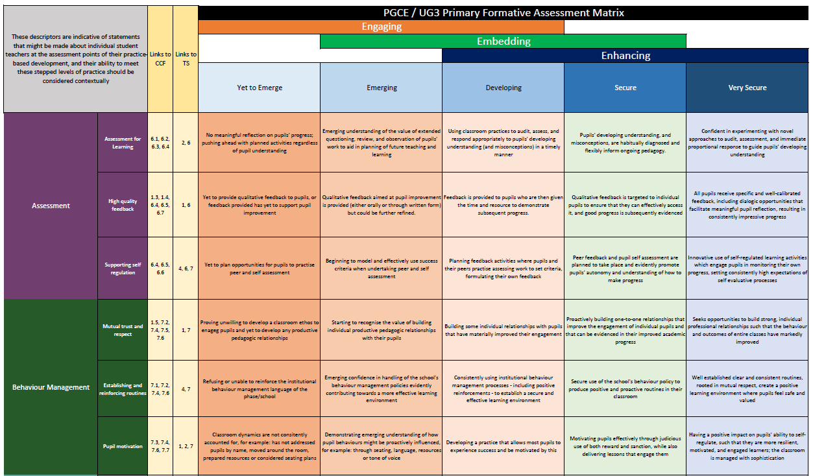
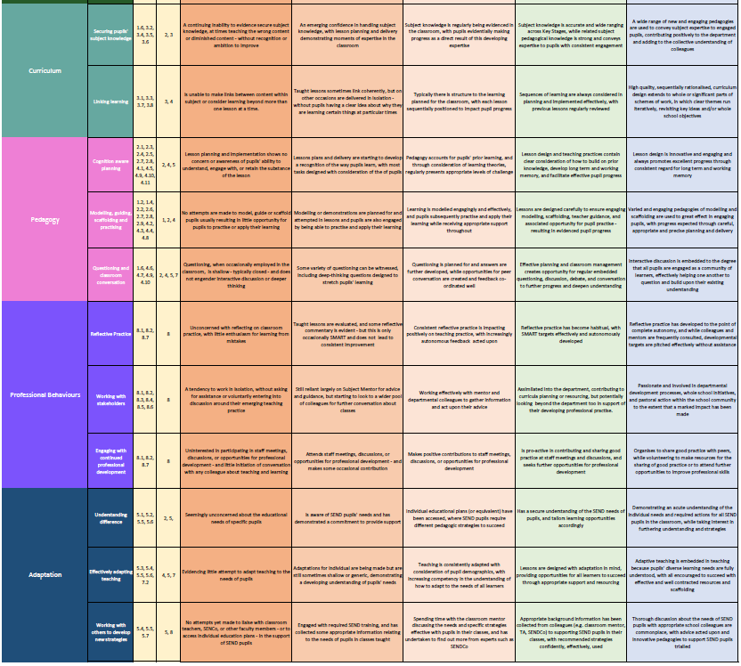

Appendix 2: Teacher Standards
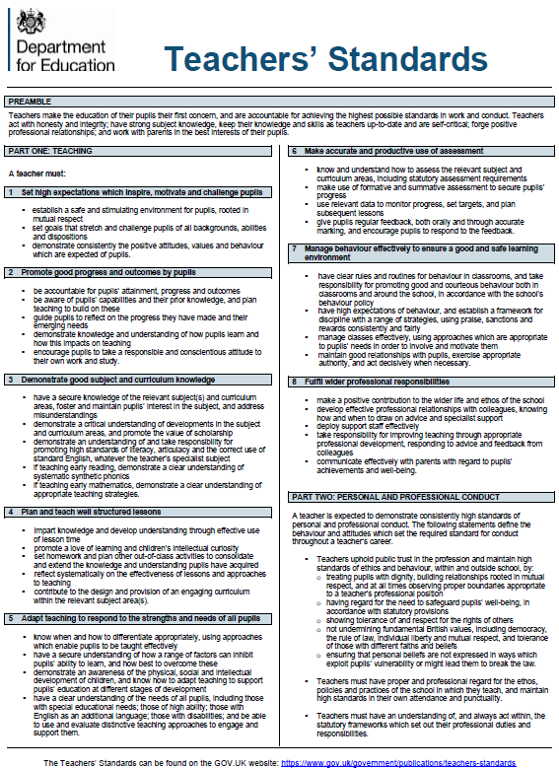

Appendix 3: UG3 Year Curriculum

Submissions |  | Professional Development –  Transition to QTS | Maths | English | Science | Foundation Subjects - Curriculum Enhancement | Teacher Researcher
Curriculum Enhancement presentation  WB: 17th Oct (wk 14) | Weeks  11-14 |  |  |  |  | Mixture of on campus and in school provision to support students to develop, plan and deliver a sequence of lessons to partner schools in a cross-curricular take-over across the school year groups. | - Deciding on a research area: what to research and with whom?  - Terminology and methodology  - Developing a proposal  - Ethical considerations  - How to collect data  - Planning a sound proposal  - Support in developing a coherent proposal with your tutor
 | Weeks 15 and 16 | Study weeks | Study weeks | Study weeks | Study weeks | Study weeks | Study weeks
Dissertation proposal  WB: 7th Nov (wk 17) | Weeks  17-22  Mon, Tues, Wed on campus  Thurs, Fri in a school |  | - Do the maths  - Geometry  - Time  - Measures  - Investigations and problem solving  - Barriers to learning mathematics  - Statistics  - Hinge Questions & Subject Knowledge  - Assessment  - Reasoning & Curiosity  - Working memory and CLT | - Phonics recap  - Phonics best practice  - Drama strategies to support reading and writing  - Planning the teaching of reading and phonics  - Exploring good writing  - Issues in the teaching of writing  - Teaching contextualised grammar  - Formative assessment of writing  - Summative assessment of writing  - Planning a unit of work | - Enhanced Science learning for all: Making science learning accessible; challenges  - Assessment in Science: Gathering and using rich data; Progression  - Children's Ideas in Science: Supporting chn to examine and develop their ideas; Scaffolding and Enhancing Children's Learning  - Enhancing explanations; anticipating misconceptions  - Adaptation for Science Learning  - Transition in Science: KS2-KS3 |  | - One to one tutorials feedback from your proposal and  planning a way forward
 | Weeks  23-25 | Study weeks | Study weeks | Study weeks | Study weeks | Study weeks | Study weeks

Submissions |  | Professional Development –  Transition to QTS |  |  |  |  | Teacher Researcher
Maths/Eng assignment  3rd Jan  -> 8th Jan  (wk 25) | Week 25 | Study week | Study week | Study week | Study week | Study week | Study week
 | Weeks  26-29 | - Planning and Instruction  - Cognition, Metacognition and Assessment  - Preparation for Professional Practice: Behaviour, Wider Responsibilities, Multi-Agency Working  - Careers: Applications, Interviews, ECT Development |  |  |  |  | - What goes where?  - Analysing data  - Findings and discussions  - How to present your data  - Support from supervisor to bring ideas together
Dissertation 21st Feb -> 26th Feb  (wk 32) | Weeks 30-32 | Study weeks | Study weeks | Study weeks | Study weeks | Study weeks | Study weeks
 | Weeks  33-45 | Extended Placement | Extended Placement | Extended Placement | Extended Placement | Extended Placement | Extended Placement
 | Week 46 | Study week | Study week | Study week | Study week | Study week | Study week
Transition to QTS presentation  WB: 5th June (wk 47)  PP3 VIVAS  WB: 5th June (wk 47) | Weeks 47 - 48 | PSHE  - Relationships and Sex  - Living in the Wider World  - Health and Wellbeing
 | Week 49 onwards | Opportunity to further extend placement (if needed)
 | End of July | Graduation

Notes:

