Student Workbook

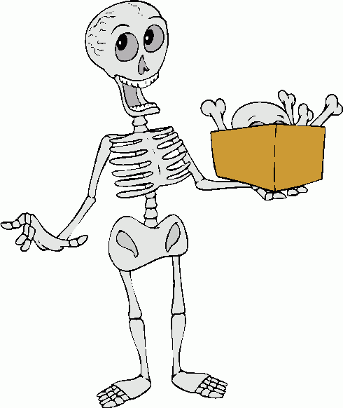

BRI Orthopaedics

Induction Checklist - Student
- Department Induction
- ID badge
- Door codes for department
- PD office
- Outpatients “library”
- Education centre
- Team induction leaflet
- Placement workbook (Orthopaedics) including weekly review sheets
- Ward induction – specify wards
- Orthopaedic Library
- Crash trolley
- Staff toilets
- Fire alarm
- Fire exit
- Location of equipment cupboards
- Equipment cupboard
- Equipment cupboard
- How to bleep
- Bleep numbers
- Physiotherapy paperwork – front sheets, NOF proforma, referral forms (copy in ward folders) and e-handover
- CISS/stats sheets

Trauma & Orthopaedics Weekly Student Feedback Week:
Strengths | Weaknesses
Opportunities | Threats

Things that went well this week:
1.
2.
3. Things to work on next week:
1.
2.
3.
Goals/Objectives review: (Are they set? Are we on course to achieve them?)

Any other comments:

Reflection done and discussed [ ]
To be reviewed on .........................................................................
Signed ......................................................................................................................... (Student)
......................................................................................................................... (Educator)

Trauma & Orthopaedics Weekly Student Feedback Week:
Strengths | Weaknesses
Opportunities | Threats

Things that went well this week:
1.
2.
3. Things to work on next week:
1.
2.
3.
Goals/Objectives review: (Are they set? Are we on course to achieve them?)

Any other comments:

Reflection done and discussed [ ]
To be reviewed on .........................................................................
Signed ......................................................................................................................... (Student)
......................................................................................................................... (Educator)

Trauma & Orthopaedics Weekly Student Feedback Week:
Strengths | Weaknesses
Opportunities | Threats

Things that went well this week:
1.
2.
3. Things to work on next week:
1.
2.
3.
Goals/Objectives review: (Are they set? Are we on course to achieve them?)

Any other comments:

Reflection done and discussed [ ]
To be reviewed on .........................................................................
Signed ......................................................................................................................... (Student)
......................................................................................................................... (Educator)

Trauma & Orthopaedics Weekly Student Feedback Week:
Strengths | Weaknesses
Opportunities | Threats

Things that went well this week:
1.
2.
3. Things to work on next week:
1.
2.
3.
Goals/Objectives review: (Are they set? Are we on course to achieve them?)

Any other comments:

Reflection done and discussed [ ]
To be reviewed on .........................................................................
Signed ......................................................................................................................... (Student)
......................................................................................................................... (Educator)

Trauma & Orthopaedics Weekly Student Feedback Week:
Strengths | Weaknesses
Opportunities | Threats

Things that went well this week:
1.
2.
3. Things to work on next week:
1.
2.
3.
Goals/Objectives review: (Are they set? Are we on course to achieve them?)

Any other comments:

Reflection done and discussed [ ]
To be reviewed on .........................................................................
Signed ......................................................................................................................... (Student)
......................................................................................................................... (Educator)

Key points for T&O physiotherapy on the wards
Work together……
- Work with nursing staff, OT and/or family members as appropriate to help patients mobilise. A team effort is required to help patients with their rehabilitation. Where possible, try and liaise early in your day with the nurses to organise seeing patients together if this is appropriate.

Respect….
- Please ask patients what they prefer to be called e.g. ‘Mrs Smith’ vs ‘Mary’

- Ensure patient’s dignity is respected at all times

It’s not just about ‘going for a walk’…..
- Consider bed/chair exercises as well as positioning/splinting to prevent contractures if a patient can’t mobilise.

- Consider adjuncts to treatment: CPM, foot pumps, ice

- Consider functional/target driven treatment plans for patients with cognitive difficulties – e.g. mobilise to another chair. Keep instructions clear and simple.

- Please don’t accept a patient refusing treatment on a daily basis without questioning: do they have capacity to understand the consequences of refusal? Are they frightened and need more time/notice of treatment? Would they respond better with family members present? Please ask for help from your senior if nothing works – don’t leave patients in bed if they are medically fit to mobilise.

Effective discharge planning…..
- Document a clear plan in the notes – people do read them! If using separate physio notes – summarise any major changes or progress/discharge plan in the medical notes.

- We aim to have an estimated date of discharge and planned discharge destination for all patients with a fractured neck of femur from day 3 post op wherever possible.

Anatomy of a long bone
Label this picture of a long bone and describe the function of each section:

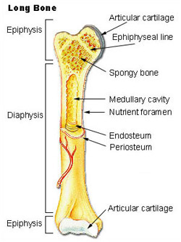
Fracture healing
Describe the process of fracture healing here and discuss this with your mentor:

Fractured Neck of Femur Information
The Normal Hip Joint
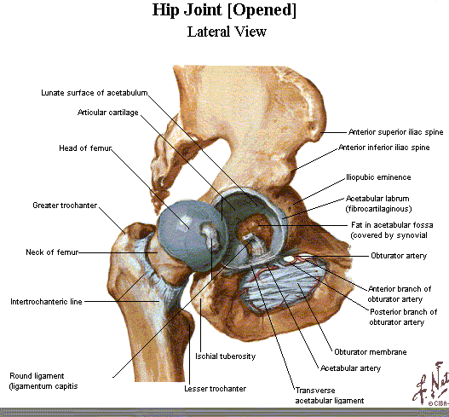

Range Of Movement required for normal gait: 37° hip flexion, 15°extension, 7° abduction, 4° internal rotation, 9° external rot. Stairs requires a further 67° flexion
A hip fracture is a fracture in the proximal end of the femur (the long bone running through the thigh), near the hip joint.
The term "hip fracture" is commonly used to refer to four different fracture patterns and is often due to osteoporosis; in the vast majority of cases, a hip fracture is a fragility fracture due to a fall or minor trauma in someone with weakened osteoporotic bone. Most hip fractures in people with normal bone are the result of high-energy trauma such as car accidents.
The mortality following a hip fracture is between 20% and 35% within one year in patients aged 82 ± 7 years old, of which 80% were women

Fractured (#) NOF’s

Intra-capsular Extra-capsular

Sub-capital Baso-cervical Inter-trochanteric Sub-trochanteric

Intra-capsular
- Just under 50% of all # NOFs
- Two types:
1. Sub-capital (junction of head and neck)
2. Baso-cervical (or Trans-cervical) (through neck)
- Prone to avascular necrosis and non-union

Extra-capsular
- Inter-trochanteric – between the trochanters
- Sub-trochanteric – below the trochanters

Less common
- Avulsion of the greater trochanter by violent adduction strain
- Blood supply usually intact

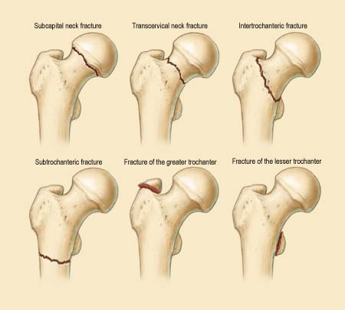

Femoral head fracture denotes a fracture involving the femoral head. This is usually the result of high energy trauma and a dislocation of the hip joint often accompanies this fracture.
Femoral neck fracture (sometimes Neck of Femur (NOF), sub-capital, or intra-capsular fracture) denotes a fracture adjacent to the femoral head in the neck between the head and the greater trochanter. These fractures have a propensity to damage the blood supply to the femoral head, potentially causing avascular necrosis.
Inter-trochanteric fracture denotes a break in which the fracture line is between the greater and lesser trochanter on the intertrochanteric line. It is the most common type of 'hip fracture' and prognosis for bony healing is generally good if the patient is otherwise healthy.
Sub-trochanteric fracture actually involves the shaft of the femur immediately below the lesser trochanter and may extend down the shaft of the femur.
Blood supply to the femoral head is key in deciding appropriate treatment.

X-ray of a Dynamic Hip Screw
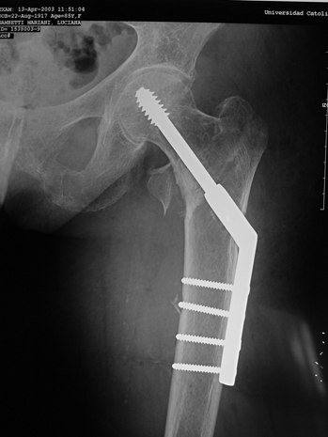

Xray of a Thompsons hemi-arthroplasty
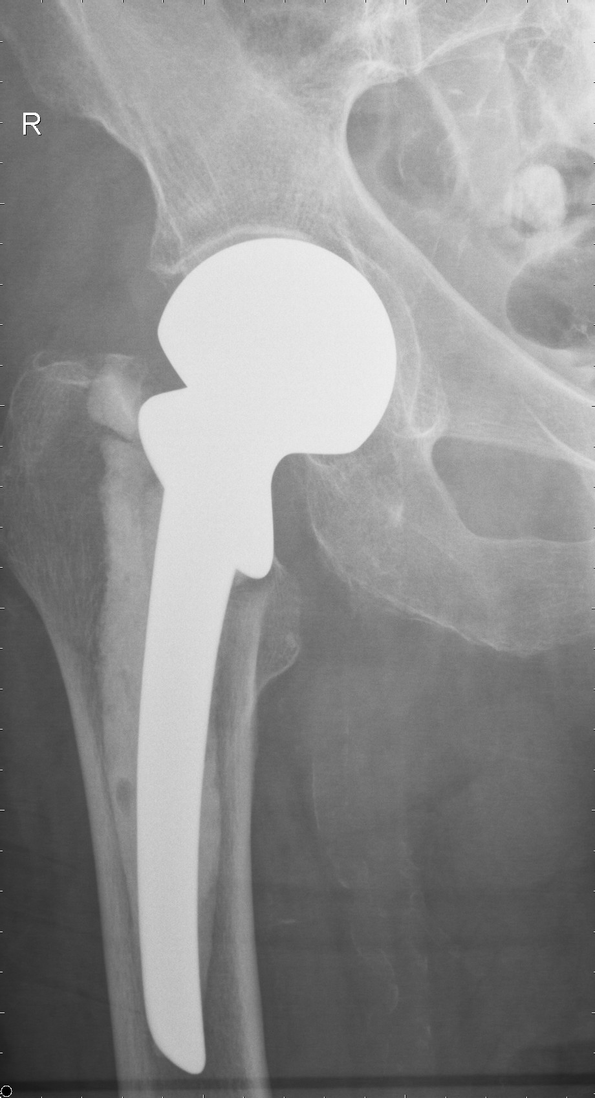

Fractured neck of femur induction information

Patient details | Fracture type | Management options & expected treatment | Potential complications
75 year old.  Normally independent  No major co-morbidities | Intra-capsular  Displaced | * | *
87 year old  Lives in a residential home, walks with frame  Has high BP, | * Expected # type & classification? | 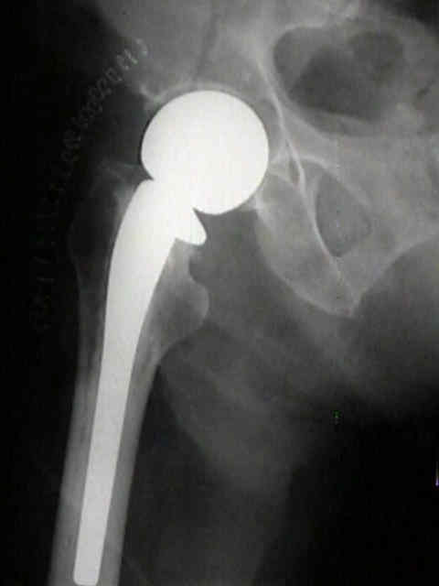  Name?  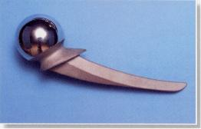 | *
60 year old  Independent  Otherwise well | Intra-capsular, minimally displaced | * | *
82 year old  Lives in a residential home, walks with a stick  Previous CVA, dementia, high cholesterol and BP | Intertrochanteric  Displaced  * Classification? | * Name? | *

Ankle Fractures
- Isolated malleolar #’s – 2/3rds of all ankle #’s
- Bi-malleolar – 1/4th
- Tri-malleolar – remaining 7%
- Open #’s – only 2% of all ankle #’s
Highest incidence in elderly women
Risk increased by smoking, High BMI, Bone weakness and falls

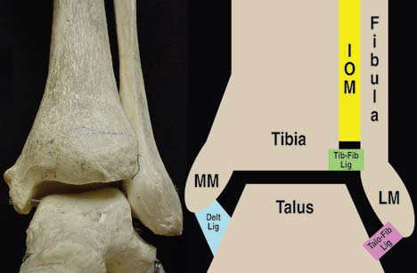

Ottawa Rules
For predicting ankle fractures –
- Unable to weight bear
- Tenderness over malleoli, navicular or base of 5th metatarsal
- Aged > 55years old
- 100% sensitivity

Ankle fracture classification
Read up on different ankle fracture classifications and describe them here:

Weber Classification
Weber A

Weber B

Weber C

Tibial Plateau Fractures

- Schatzker classification
  - I: Lateral split
  - II: Lateral split with depression
  - III: Pure lateral depression
  - IV: Pure medial depression
  - V: Bi-condylar
  - VI: Split extends to meta-diaphysis

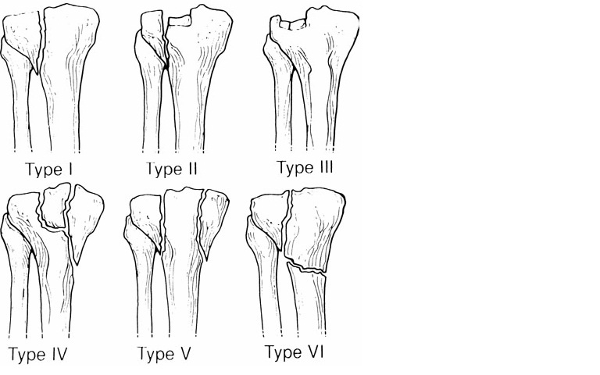

- How would you manage each type of fracture?

Ilizarov / Taylor Spatial Frame Information

Gavriil Abramovich Ilizarov was a Russian physician, known for inventing the Ilizarov apparatus for lengthening limb bones.

In 1961 he created the Kurgan Center of the Restorational Surgery and Orthopaedic. He was the head of this centre until 1991. The Center has become one of the largest orthopaedic in the world.
Ilizarov discovered that by carefully severing a bone without severing the periosteum around it, one could separate two halves of a bone slightly and fix them in place, and the bone would grow to fill the gap between the broken bones. He also discovered that bone regrows at a fairly uniform rate across people and circumstances.

These experiments led to the Ilizarov apparatus, which holds a severed bone in place, by the framework and pins through the bone, and this separates the bone by a tiny amount by repeating this over time, at the rate of the bone's regrowth, it is possible to extend a bone by a desired amount.

Periosteum is a membrane that lines the outer surface of all bones, except at the joints of long bones.
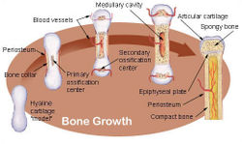

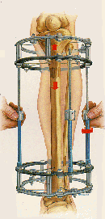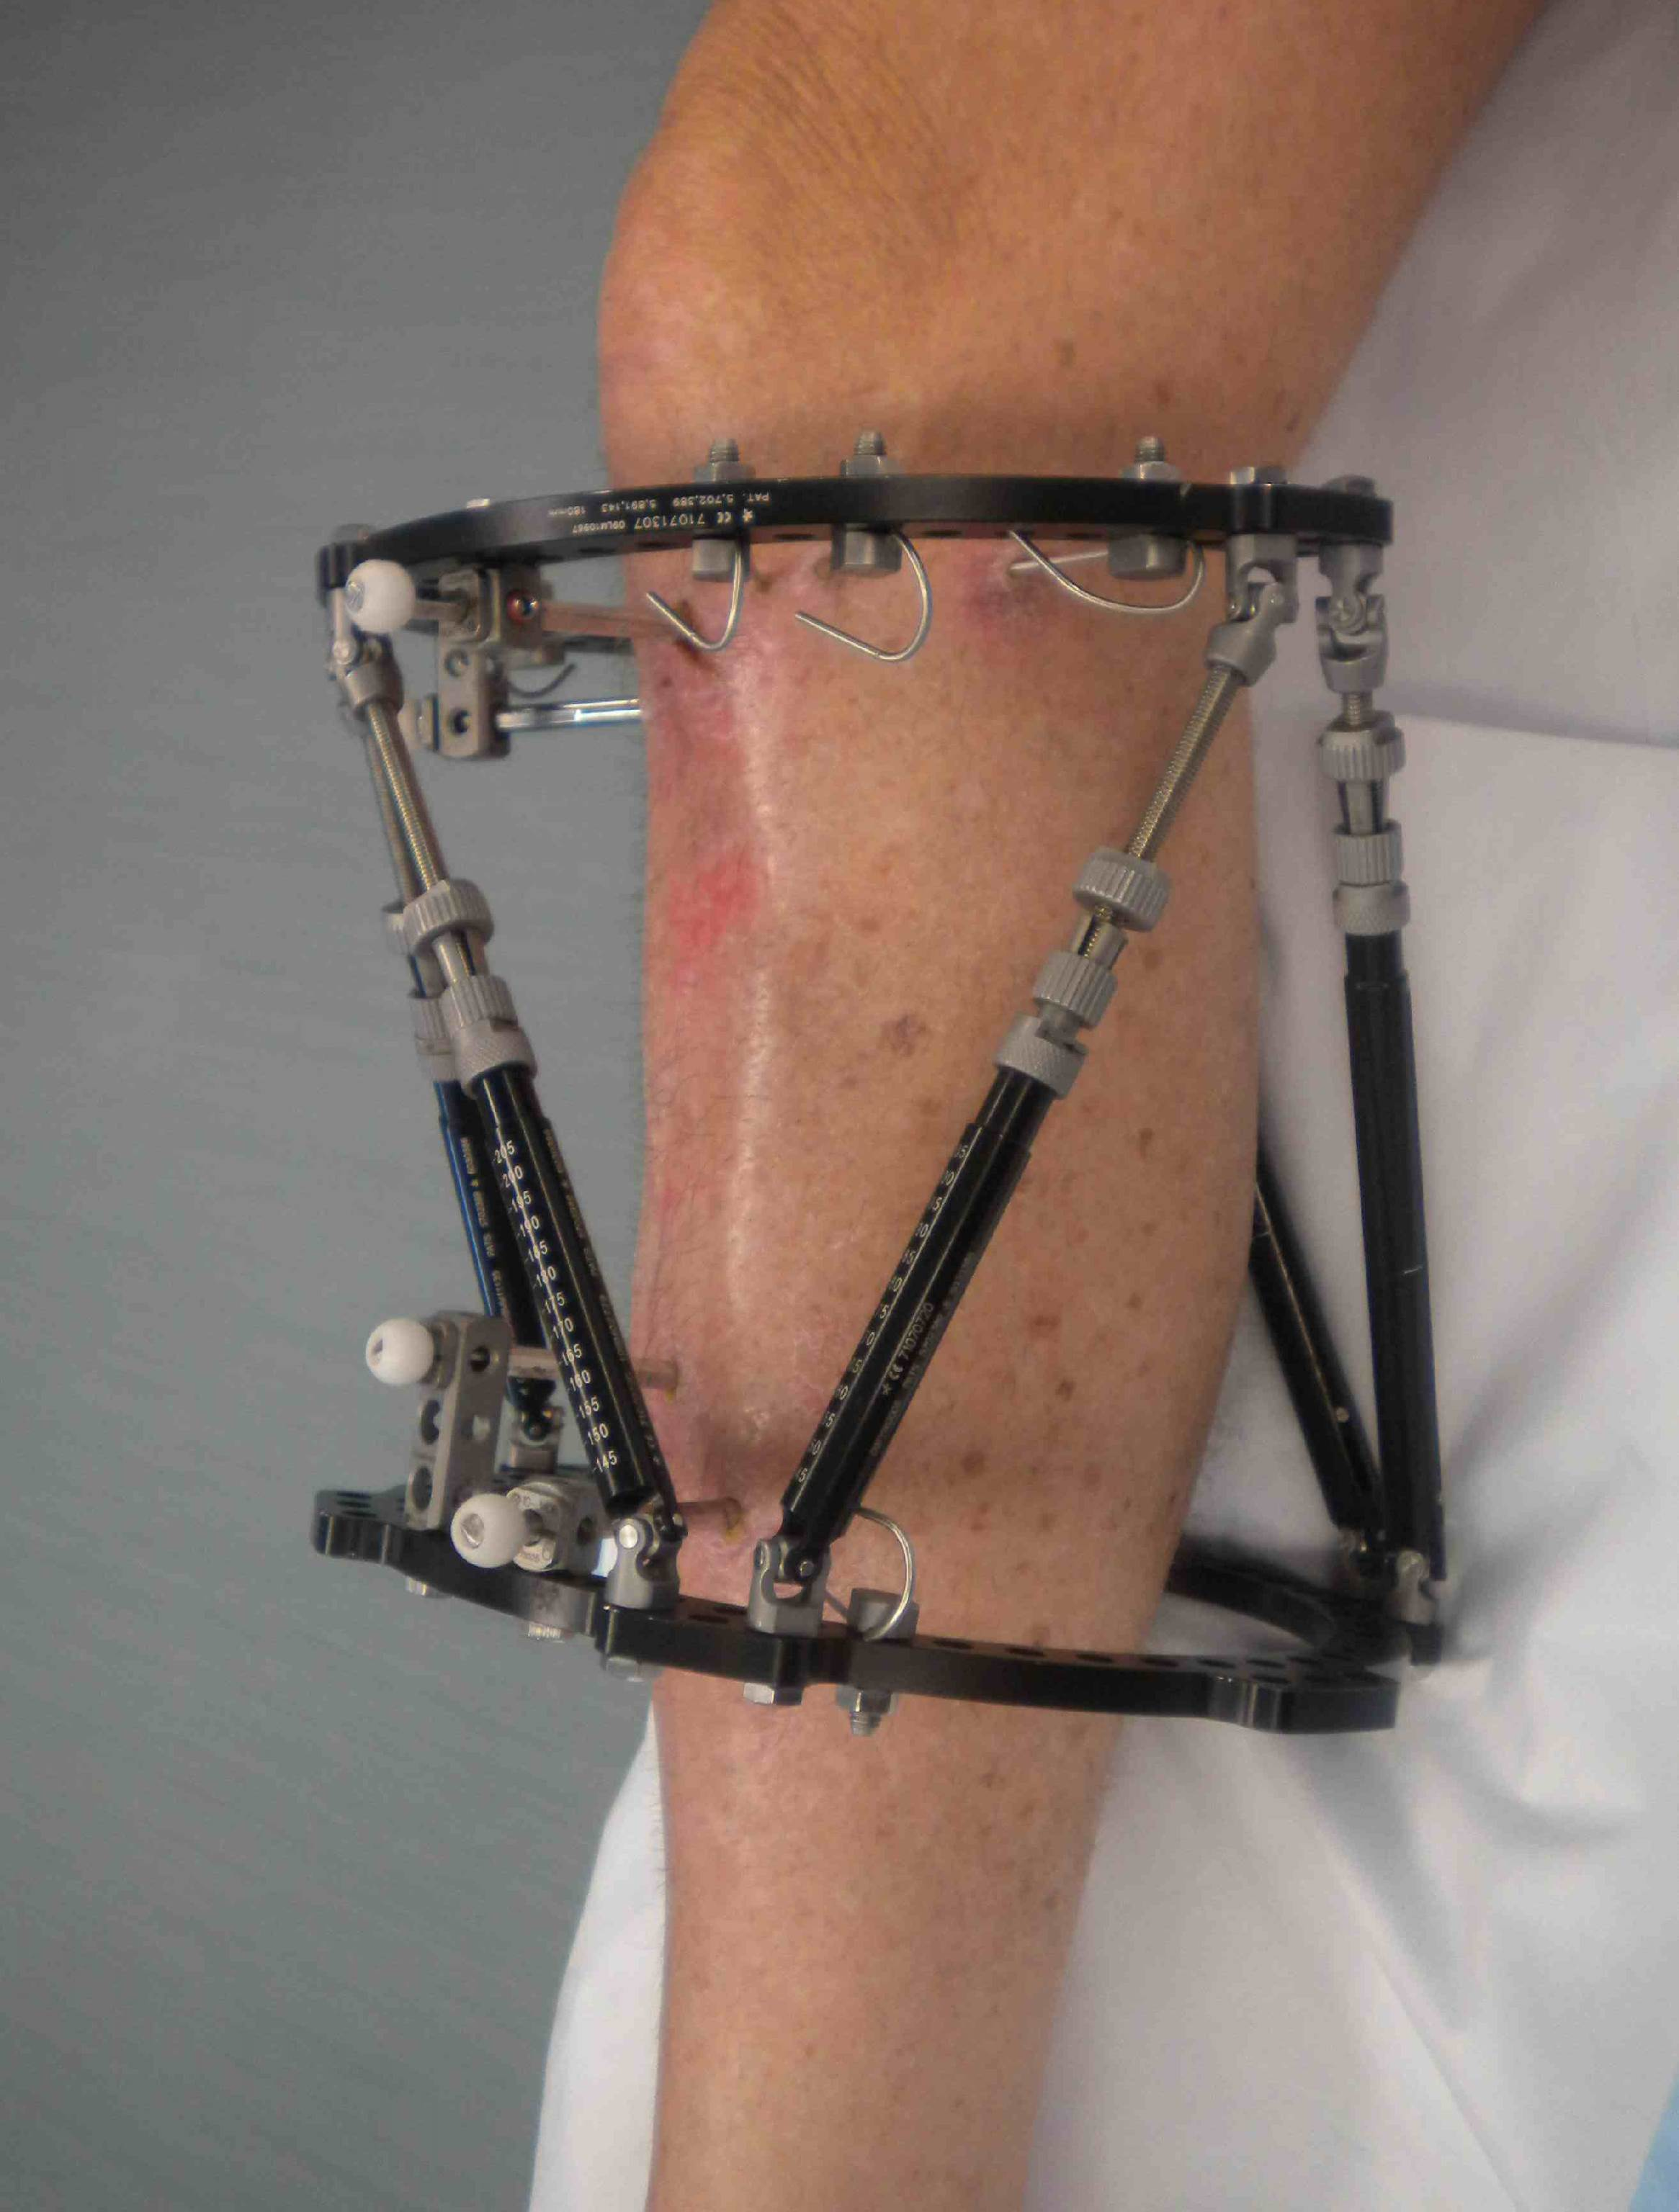

The TSF is a specialized form of external fixator. Stainless steel rings are fixed to the bone via stainless steel heavy-gauge wire which are known as pins. The rings are connected to each other with threaded rods attached through adjustable nuts. The circular construction and tensioned wires of the Ilizarov apparatus provide far more structural support than the traditional mono-lateral fixator system. This allows early weight bearing. The frame can be used to support a fractured limb, but it is most commonly used to correct deformities.

The procedure consists of an initial surgery, during which the bone is surgically fractured and the ring apparatus is attached. As the patient recovers, the fractured bone begins to grow together. While the bone is growing, the frame is adjusted by means of turning the nuts, thus increasing the space between two rings. As the rings are connected to opposite sides of the fracture, this adjustment, done daily, moves the now-healing fracture apart by approximately one millimetre per day. The incremental daily increases result in a considerable lengthening of the limb over time. Once the lengthening phase is complete, the apparatus stays on the limb to facilitate healing. The patient can move about on crutches and pain is lessened. Once healing is complete, a second surgery is necessary to remove the ring apparatus. The result is a limb that is significantly longer. Additional surgery may be necessary, in the case of leg lengthening, to lengthen the Achilles tendon to accommodate the longer bone length. The major advantage of this procedure is that because the apparatus provides complete support while the bone is recovering the patient can remain active aiding recovery.
A further use is of bone transport, whereby a defect in a long bone can be treated by transporting a segment of bone, whilst simultaneously lengthening regenerate to reduce the defect and finally dock with the other segment, producing a single bony unit.
While the Ilizarov apparatus is minimally invasive (no large incisions are made,) it is not free of complications. Pain is common and can be severe, but is treatable with analgesics. Careful attention to daily cleaning and hygiene is necessary to prevent pin site infection. Other complications include swelling and muscle transfixion.

The Taylor Spatial Frame (TSF) is an external fixator and shares a number of components and features of the Ilizarov apparatus The TSF is a hexapod device based on a Stewart platform and was invented by Dr Charles Taylor. The device consists of two TSF rings made of aluminium connected together by 6 struts. Each strut can be independently lengthened or shortened. Connected to a bone by wires or half pins, the attached bone can be manipulated in 6 axes (anterior/posterior, varus/valgus, lengthen/shorten.) Both angular deformities and translational deformities can be corrected with the TSF.
It is used in both adults and children. It is used for the treatment of acute fractures, mal-unions, non-union and congenital deformities. It can be used on both the upper and lower limbs. Specialized foot rings are also available for the treatment of complex foot deformities.

Once attached to the bone, the deformity is characterized by studying the postoperative x-rays. The angular and translational deformity values are then entered into specialized software along with parameters such as the ring size and initial strut lengths. The software then produces a "prescription" of strut changes that the patient follows. The struts are adjusted every day by the patient. Typically, correction of the bone deformity will take 3-4 weeks. Once the deformity has been corrected, the frame is then left on the leg whilst the bone heals, typically this will take 3-6 months, depending on the nature and degree of deformity.

X-ray of TSF

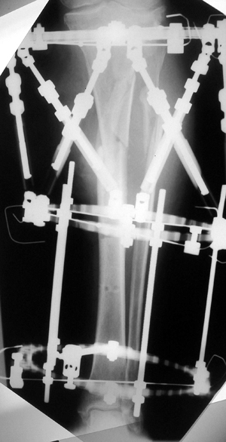
Self-study topics
When you have spare time why not do some reading on some of the following topics and discuss what you find with your supervisor?
- Tibial Plateau fractures
- Pathological fractures
- Multi-trauma
- Humeral fractures
- Wrist fractures
- Knee injuries and surgical techniques
- ACL protocols
- PCL protocols
- Elbow trauma
- Quads tendon repairs
- Fracture complications
- Local discharge destinations
- Effects of smoking on fracture healing
- Soft tissue injuries
- Maxillo-facial
- Shoulder replacement
- Total hip replacement
- Total knee replacement
- Cellulitis
- Low back pain – causes, treatments, physio input
- Plastic surgery
- Finger surgery – lacerations, tendon repairs

Terminology sheet
Find the definitions for the terms below – look in the outpatient department for some books or discuss with your supervisor.
- Avascular necrosis

- Bone transport

- Compartment Syndrome

- DVT

- Erythema

- Fragility fracture

- Girdlestone

- Half pin

- Ischemia

- Joint hypermobility syndrome

- K-wire

- Lisfranc fracture

- Metaphysis

- Navicular

- Osteotomy

- PE

- Q-angle

- Reactive arthritis

- Secondary bone healing

- Taylor Spatial Frame

- Ultrasound for MSK

- Varus/Valgus

- Whiplash

- X-Ray

- Y shaped fracture

Article critique

