Nursing
Practice Assessment Document 1.0 (PAD)

Guide to using the South PAD

BSc (Hons)/PG Dip/MSc/MSci Programmes
South PAD 1.0, Future Nurse: Standards of proficiency for registered nurses, (NMC 2018)

This guide to the South PAD Practice Assessment Document for Nursing has been adapted from the guide to the Pan London Practice Assessment Document which was completed by the Pan London Practice Learning Group in collaboration with practice partners, mentors, academic staff, students and service users across the London Region. This work has been led by Jane Fish as Project Manager. The South PAD Project Team has also collaborated with practice partners, mentors, academic staff, students and service users across the South Region in the adaptation process.

Completing the Practice Assessment Document

Contents | Page number
Introduction | 4-5
Criteria for assessment in practice | 6
Criteria for assessment in practice – overall framework Parts 1 – 3 | 7
Student responsibilities | 8
Practice Supervisor responsibilities | 9
Practice Assessor responsibilities | 10
Academic Assessor responsibilities | 11
Document signatories and checklist for assessed documents | 12
Orientation | 13
Initial, mid-point and final interview | 14
Professional values | 15
Patient/Service User/Carer Feedback Form | 16
Record of working with and learning from others/inter-professional working | 17
Record of communication and additional feedback | 18
Record of peer feedback – Part 2 and Part 3 only | 19
Proficiencies | 20
Episode of care | 21
Medicines Management | 22
Progression towards registration – record of weekly meetings in final placement | 23
Action plan | 24
Ongoing achievement record (OAR) | 25
How does the PAD relate to different fields of practice? | 26-29

Introduction

The purpose of this guide is to provide guidance for the completion of the South PAD Practice Assessment Document 1.0. General guidelines are provided for each element within the PAD. This guidance should be read alongside specific instructions that may apply to individual Universities.

The South PAD 1.0 has been developed to ensure that student nurses are prepared to successfully meet the Future Nurse: Standards of proficiency for registered nurses (NMC 2018) at the point of registration. The NMC standards specify the knowledge and skills that Registered Nurses must demonstrate when caring for people of all ages and across all care settings and comprise seven platforms and two annexes. The role of the Nurse in the 21st century is to provide care for people who have complex mental, physical, cognitive and behavioural care needs across a range of settings including people’s own homes, in the community or hospital or any health care setting.

The platforms are:
- Being an accountable professional
- Promoting health and preventing ill health
- Assessing needs and planning care
- Providing and evaluating care
- Leading and managing nursing care and working in teams
- Improving safety and quality of care
- Coordinating care
Annexe A: Communication and relationship management skills Annexe B: Nursing procedures

The outcome statements within the standards of proficiency apply across all fields of nursing practice (Adult, Children, Learning Disabilities and Mental Health) and all care settings as Registered Nurses must be able to meet the person-centred, holistic needs of the people they encounter in their practice who may be at any stage of their life and who may have a range of mental, physical, cognitive or behavioural health challenges.

The annexes within the standards of proficiency also apply across all fields and demonstrate what Registered Nurses should be able to demonstrate at the point of Registration. The level of expertise and knowledge required for both annexes will vary dependent on the chosen field(s) of practice. Registered Nurses must be able to demonstrate the ability to undertake these skills and procedures at an appropriate level for their intended field(s) of practice.

Practice Supervisors, Practice Assessors and Academic Assessors have an important role in supporting and guiding the student through their learning experience. This includes facilitating any reasonable adjustments the student may require to achieve the maximum benefit from the placement. Descriptions of these roles can be found within this guide.

As well as undertaking the required assessments, the role of the Practice Supervisor and Practice Assessor also includes identifying relevant learning opportunities and creating learning and development plans with the student.

The document has been designed around the following Components of Assessment and Feedback:

  - Initial, Mid-Point and Final Interviews per placement
  - Professional Values
  - Proficiencies
  - Episode(s) of Care
  - Medicines Management
  - Patient/Service User/Carer Feedback Form
  - Record of working with and learning from others/interprofessional working
  - Record of communication/additional feedback
  - Ongoing Achievement Record

[N.B. The screen shots currently include the Mapping Codes from the Future Nurse: Standards of proficiency for registered nurses (NMC 2018). Following validation the mapping codes are removed from the documents. The screen shots in this Guide will be updated following validation.]

Criteria for Assessment in Practice

Within the PAD three key statements have been developed to reflect the level of performance that the student is required to demonstrate at the end of each Part, as well as the level of assistance that may be required at each stage where the student by the end of the Part is practising independently, competently and confidently. The following three levels of performance are to be met by the end of each Part: refer to table 1

By the end of Part 1 | Guided participation in care and performing with increasing confidence and competence
By the end of Part 2 | Active participation in care with minimal guidance and performing with increased confidence and competence
By the end of Part 3 | Practising independently with minimal supervision and leading and co-ordinating care with  confidence

Table 1

In addition to achieving the required level of performance at the end of the Part the student is assessed against a specified set of criteria related to knowledge, skills, attitudes and values for each component of assessment within the PAD. These criteria are used to assess the student on different placements across the year as they work towards the overall performance level to be achieved by the end of the Part. For details of the criteria in each Part refer to Table 2.

If the student’s performance gives cause for concern at the mid-point interview or at any point during the experience feedback must be given and an action plan written to enable the student to address this prior to the final interview. The Practice Assessor must communicate with and involve the Academic Assessor in this process.

Within the PAD there are guidelines relating to how the assessment is managed within each University, and the student should ensure that they have read and understood these.

Statement regarding the use of the term “Parts”

There are three Practice Assessment Documents in total, which incorporate the range of Future Nurse Standards of proficiency (NMC 2018). “Parts” in this context is used to represent the range of outcomes to be achieved by students at different levels. These parts may differ from the parts of the education programme that will be defined locally by each university provider.

Criteria for Assessment in Practice Overall Framework Parts 1 – 3
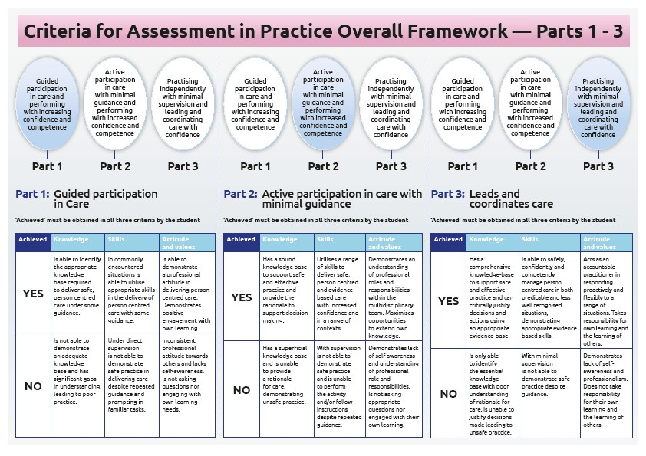
Table 2

Student Responsibilities
You should take responsibility for your own learning and know how to access support and;  - Engage positively with all learning opportunities  - Understand the assessment requirements  - Work with and receive written feedback from a range of staff (including identified Practice Supervisors) and Service-Users  - Reflect on your own learning  - Provide feedback on learning experience  FAQs  Q: When should I contact my allocated placement?  A: It is advisable to contact your allocated placement in advance of starting your placement to obtain the information you need to enable you to prepare.  Q: Will I have a named contact on placement?  A: You will have a nominated person to support you and address any concerns. This could be a Placement Manager, Ward Manager, Team Leader, Service Manager or other.  Q: Who will supervise me on placement?  A: You will be supported by a number of Practice Supervisors who will support your learning and can contribute to assessment. (refer to page 8)  Q: Who will assess me on placement?  A: You will have a nominated Practice Assessor for your placement, who is responsible for assessing and confirming proficiency and achievement. The Practice Assessor will liaise with the Practice Supervisor and Academic Assessor to obtain feedback on your progress. (refer to page 9)  Q: Will there be support from the University when on placement? A: You will have a named Academic Assessor for each Part of the programme. The Academic Assessor will liaise with your Practice  Assessor. If you have any concerns on placement you should raise these with the university as soon as possible. (refer to page 10 and university guidelines) | 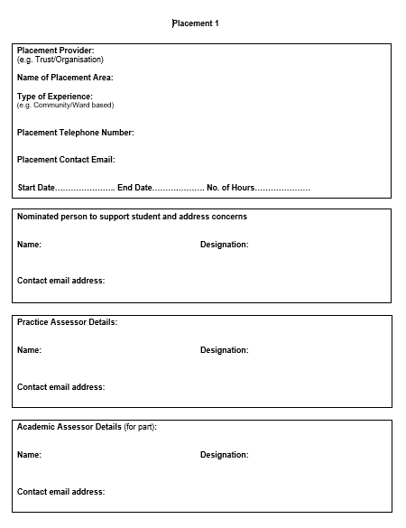

Practice Supervisor Responsibilities
Practice Supervisors (PS) are Registered Nurses or Midwives or Registered health or social care professionals. They have current knowledge and experience and are appropriately prepared for the role;  - Ensures learning opportunities are facilitated  - Contributes to assessment and records regular feedback  - Seeks feedback from other supervisors  FAQs  Q: What is my role in supporting the student?  A: You have responsibilities for overseeing the student’s progress during the placement. You will undertake the initial interview in the placement with the student which includes supporting the student to identify their learning opportunities and completion of the learning plan.  Q: What is my role in assessing the student?  A: The Practice Assessor has responsibility for student assessment. Practice Supervisors have an important role in contributing to assessment and giving regular feedback and the following can be undertaken by the Practice Supervisor to contribute to the student’s assessment;  - Initial interview on placement  - Professional Values at midpoint interview  - Proficiencies as appropriate and relevant to your scope of practice and professional role  Q: What is my relationship with other identified roles?  A: You will record feedback on the student’s progress and liaise with other Practice Supervisors and the Practice Assessor to give feedback to inform the Practice Assessor’s decisions.  Q: What if I am not a registered nurse and supervising the student? A: A range of Registered health or social care professionals can support and supervise student learning and contribute to the student’s assessment within their scope of practice. | 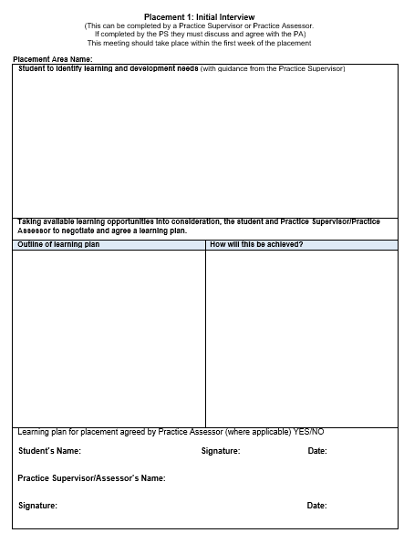

Practice Assessor Responsibilities
Practice Assessors (PA) are Registered Nurses or Midwives with current knowledge and expertise and are appropriately prepared for the role;  - Conducts assessments, informed by feedback from Practice Supervisors  - Makes and records objective decisions, drawing on records, observations, student reflection and other resources  - Periodically observes the student  - Gathers and coordinates feedback from Practice Supervisors and other relevant people  - Schedules communication with Academic Assessors at relevant points  FAQs  Q: What is my role in assessing the student?  A: You have responsibility for student assessment and will liaise with the Practice Supervisors to obtain feedback and Academic Assessors to discuss student achievement and progression. You will review assessment documentation in the PAD that has been completed by a range of other health or social care professionals who have contributed to aspects of assessment.  Q: What specific elements do I need to assess and document? A: The Practice Assessor assesses;  On each placement:  - Initial interview (can be undertaken by Practice Assessor or Practice Supervisor; if PS undertakes, must be agreed by PA)  - Midpoint interview  - Professional Values at final interview  - Final interview  - Confirmation of proficiencies  During the part:  - Episodes of Care and Medicines Management  Q: What is my responsibility when a student’s performance causes concern?  A: If a student requires an Action Plan, you should liaise with the  Academic Assessor. Depending on the AEI and the local practice placement policy you may have to inform the nominated person. | 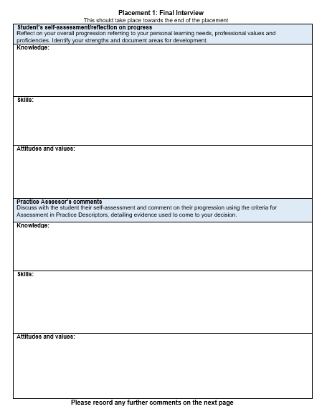  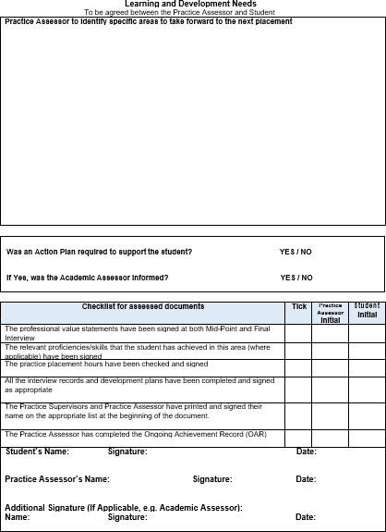

Academic Assessor Responsibilities
Academic Assessors are Registered Nurses or Midwives and are nominated for each Part of the programme and are appropriately prepared for the role;  - Works in partnership with the Practice Assessor to evaluate and recommend the student for progression for each part of the programme  - Has understanding of the student’s learning and achievement in practice  - Enables scheduled communication and collaboration between Academic and Practice Assessors  FAQs  Q: What is my role in relation to student assessment?  A: The student has an Academic Assessor for each Part of the programme and will provide continuity and have an overview of student achievement to inform progression. If there is cause for concern in relation to the student’s performance you should be involved in agreeing an Action Plan.  Q: Who will I liaise with?  A: You will communicate and collaborate with the Practice Assessor at relevant scheduled points during the Part. This may be in person, via email or telephone as appropriate.  Q: What is my responsibility in relation to the student’s progression towards registration?  A: In Part 3 to ensure the student is able to provide care, lead and co- ordinate care confidently they will reflect, receive feedback and record achievements for the Practice Assessor to confirm that the student is practising independently with minimal supervision and leading and coordinating care with confidence. The Academic Assessor will review and confirm the overall achievement in the PAD and recommend progression to registration in the OAR. | 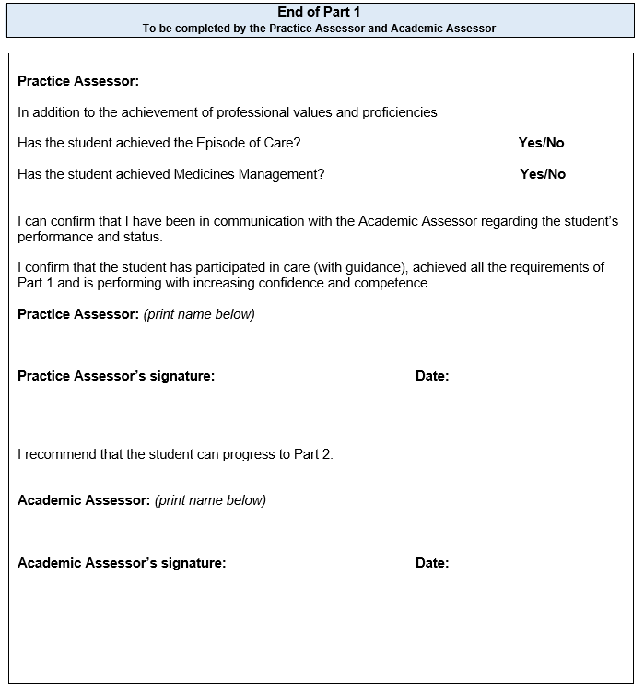

Document Signatories and Checklist for assessed documents
There are separate pages for Practice Supervisors, Practice Assessors and Academic Assessors to record information. It is your responsibility to complete these details.  Any Registered professional who writes in the PAD must complete the appropriate signatories page. This includes the record of orientation, record of communication and/or record of practice hours.  This is required by the University to cross reference and prevent falsification of records.  Please ensure that you insert your name, signature and date as required throughout the document.  Checklist for assessed documents:  At the end of each placement in the final interview, the Practice Assessor completes the checklist to confirm all components have been assessed and records signed. | 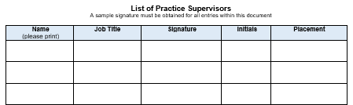  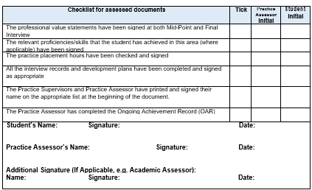

Orientation
There are some elements of orientation that must be completed on the first day on placement. Refer to orientation page in the Practice Assessment Document.  FAQs  Q: Who can orientate the student and complete this page?  A: An appropriate member of staff familiar with the area, as identified by the nominated person/local manager can complete the student orientation and sign the appropriate section of the PAD.  Complete the appropriate signatory page. | 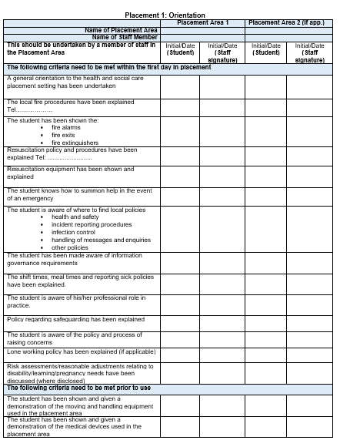

Initial, Mid-point and Final Interview
The interviews provide a formal record of student learning, reflections and achievement. Students are encouraged to take responsibility for their own learning and record reflections.  Initial interview:  This is completed by the student with support from the Practice Supervisor or Practice Assessor who will identify the learning opportunities available during the placement and will reflect on their achievements. If the Practice Supervisor completes the initial interview with the student this needs to be confirmed by the Practice Assessor.  Mid-point interview:  This is completed by the student and the Practice Assessor who will review progress and if there are causes for concern the Practice Assessor will liaise with the Academic Assessor and complete an action plan.  Final interview:  This is completed by the student and the Practice Assessor who will review progress and confirm achievement. At the end of the interview the Practice Assessor must complete the checklist for assessed documents. | 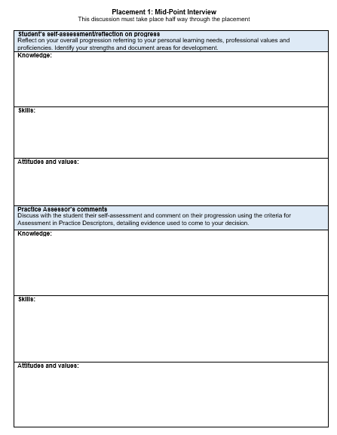

Professional Values
Students are required to demonstrate high standards of professional conduct at all times during their placements. Students should work within ethical and legal frameworks, and be able to articulate the underpinning values of The Code (NMC, 2015). The Professional Values reflect a number of proficiency statements and are captured under the four sections of The Code.  Student reflection on meeting Professional Values:  The student selects one example from practice on each placement to demonstrate how they practise within The Code. Confidentiality in relation to people receiving care and service providers should be maintained. For each placement a different area of The Code should be selected to reflect on.  Student achievement:  Where other components have been assessed and achieved e.g. a proficiency assessed at the beginning of the Part, the student needs to demonstrate continued competence and confidence in the proficiency. Professional Value statement 8 enables the assessor to ensure and record that the student is meeting this requirement.  FAQs  Q: Who assesses the professional values?  A: The Practice Supervisor or Practice Assessor can assess the mid- point professional values. If the Practice Supervisor assesses the mid- point this will be reviewed and agreed by the Practice Assessor. The final Professional Values on each placement are assessed by the Practice Assessor who will discuss and review with the student their reflection. If there are any concerns raised these should be discussed with the Academic Assessor. | 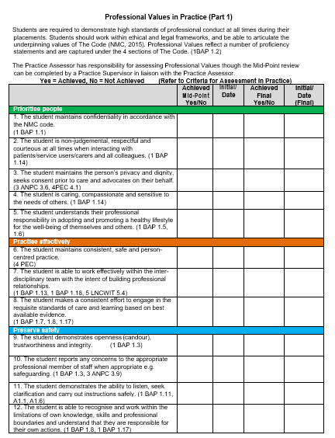  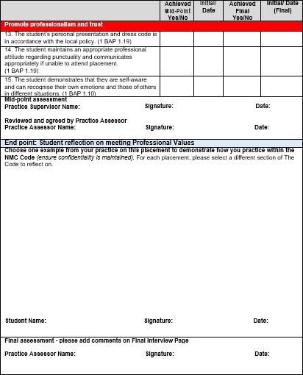

Patient/Service User/Carer Feedback Form
Within each placement there is a page for the student to receive feedback directly from someone they have cared for and/or carers. Practice Supervisors or Practice Assessors are asked to support students by facilitating this and asking people or their families to complete the form and they should sign this on completion. It may not be possible to have this completed in every placement.  FAQs:  Q: Who asks the person receiving care or carer to complete the form?  A: The Practice Supervisor/Practice Assessor should obtain consent from patients/service users/carers who should feel able to decline to participate.  Q: Does the person receiving care or carer have to sign the form?  A: No.  Q: How is the feedback used in the assessment process by the Practice Supervisor and Practice Assessor?  A: The student will reflect on the feedback provided by the patient/service user/carer and discuss the outcomes, including any changes to practice that need to be made which can be included in the interviews or in an Action plan. | 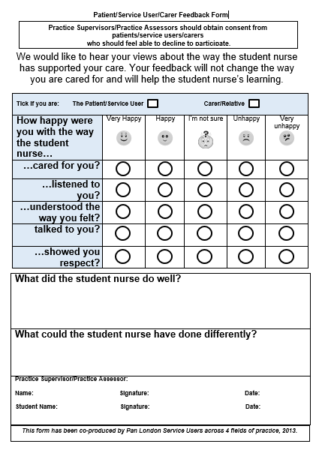

Record of Working with and Learning from Others/Inter-professional working
Students will have opportunities across all Parts to work with other professions across a range of teams and agencies and will be able to gain an understanding of the different roles and responsibilities and importance of teamwork in providing person centred care.  Student reflection:  Students should reflect on their learning when working with members of the multi-disciplinary team and document this. The Practice Supervisor will discuss the student’s reflection and comment on their experience.  FAQs  Q: How are the reflections used in the assessment process by the Practice Supervisor and Practice Assessor?  A: The Practice Supervisor will discuss the student’s reflection on their learning from others and provide relevant feedback to the Practice Assessor as appropriate. The Practice Assessor will review documented records where the student has worked with other health and social care professionals and incorporate into assessment where appropriate. | 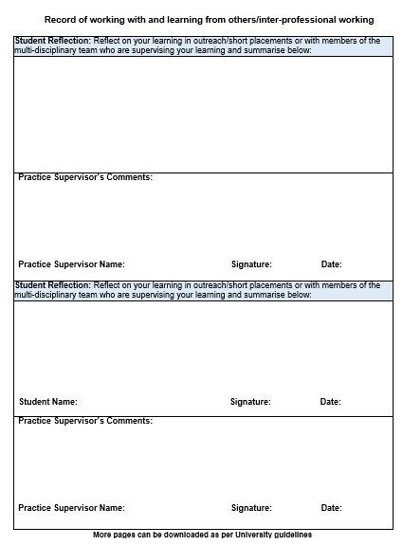

Record of Communication and Additional Feedback
These records can be completed by Practice Supervisors, Practice Assessors, Academic Assessors or any other members of the team involved in the supervision and assessment of the student.  Complete the relevant signatory page.  This is for additional feedback that has not previously been documented in the PAD.  FAQs  Q: Should other members of the team be Registered professionals? A: No. It may be appropriate for an experienced health care assistant to give feedback on working with the student. However they would not be contributing to assessment decisions.  Q: What type of information should be recorded?  A: Any relevant information that can be used in the assessment process, or that records the student’s progression. | 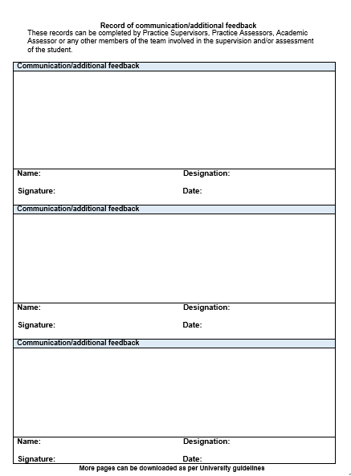

Record of peer feedback – Part 2 and Part 3 only
These records can be completed by the student’s peers i.e. other students who have worked alongside you or have had the opportunity to discuss your learning needs with you. If you have facilitated a teaching session on placement you can use this form below to obtain feedback.  FAQs  Q: Which students can complete peer feedback?  A: Any student in practice that you have worked with regularly. This could be Nursing, Midwifery, Allied Health, Medical and/or Social Work students.  Q: How is peer feedback used in the assessment process by the Practice Supervisor and Practice Assessor?  A: The Practice Supervisor will discuss with the student the feedback they have received from peers in relation to how they support other student’s learning in practice and facilitate teaching. The Practice Assessor will review documented peer feedback where the student has received feedback from other students and incorporate into assessment where appropriate. | 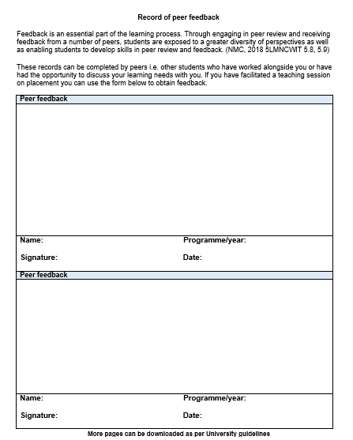

Proficiencies
Assessment of proficiencies are undertaken across the Part. These can be assessed in a range of placements. If a proficiency is assessed as achieved early in the Part it is expected that the student maintains that level of competence and could be re-assessed in subsequent placements during the part. This is underpinned by Professional Value 8.  FAQs  Q: Who assesses the Proficiencies?  A: Practice Supervisors and other Registered health or social care professionals can contribute to the assessment of proficiencies, within their scope of practice. Practice Assessors will also assess proficiencies and have responsibility for confirming that proficiencies have been met at the final interview.  Achievement of Parts 2 and 3 proficiencies:  To support the student progressing effectively through the programme and in utilising the valuable opportunities available across a range of placements certain Proficiencies have been identified that can be met in Part 2 OR Part 3. These are listed in the Part 2 and Part 3 documents and the OAR. The Practice Assessor needs to complete this at the end of Part 2 and Part 3. Any Proficiencies not met in Part 2 are then identified as the student needing to achieve these in Part 3.  Q: How will the student know which Proficiencies can be undertaken in Part 2 or Part 3?  A: The Practice Supervisor or Practice Assessor will discuss the learning opportunities on the placement with the student during the initial interview.  Q: How will the student, Practice Assessor and Academic Assessor know if the Proficiencies have been achieved in Part 2 or are being carried forward to Part 3?  A: This will be recorded both in the PAD and the OAR. | 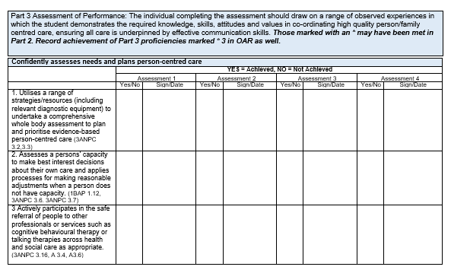  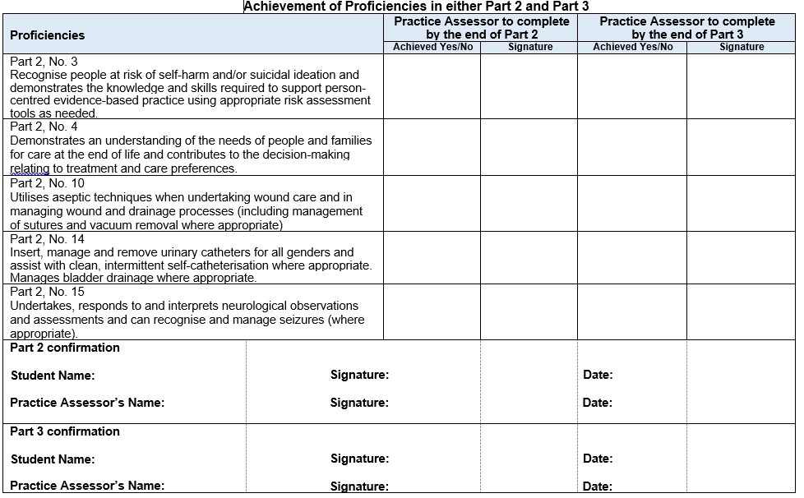  OAR

Episode of Care
Episodes of Care are holistic assessments which enable the student to demonstrate progression across a number of platforms and must be achieved by the end of the Part. Effective communication and relationship management skills underpin all aspects of care. This assessment must be completed by a Practice Assessor.  Part 1:  Formative - episode of direct care meeting the needs of a person receiving care.  Summative - episode of direct care meeting the needs of a person receiving care.  Part 2:  Episode 1 - group of people receiving care or individual with complex care needs.  Episode 2 - group of people receiving care with increasingly complex health and social care needs.  Part 3:  Episode 1 - Supervising and teaching a junior learner in practice, based on the delivery of direct person-centred care.  Episode 2 - organisation and management of care for a group/caseload of people with complex care covering all seven platforms.  The student and the Practice Assessor should identify the appropriate placement and episode of care to complete this assessment. As there is only one opportunity for assessment the planning should take this into consideration to maximise the learning for the student.  Student reflection:  An integral component of this assessment is the student reflection on the delivery of person centred care. | 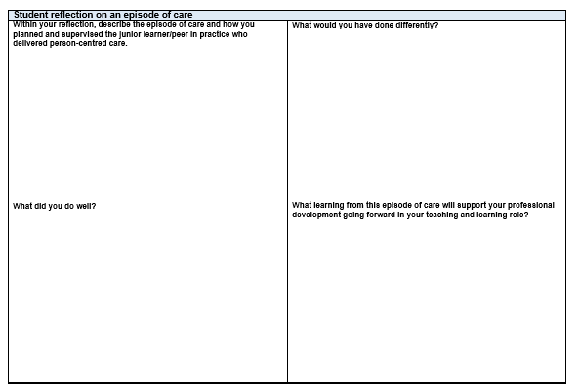  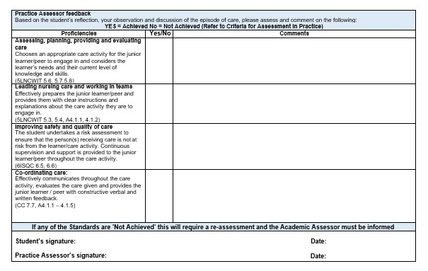

Medicines Management
The students is required to undertake a Medicines Management assessment during each Part. This assessment must be completed by a Practice Assessor.

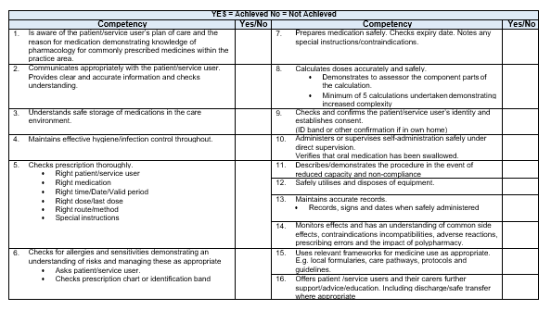
The student and the Practice Assessor should identify the appropriate placement to complete this assessment. As there is only one opportunity for assessment the planning should take this into consideration to maximise the learning for the student. The student should be allowed a number of practice opportunities to administer medicines under supervision prior to this assessment.

By the end of Part 3 the student should be consolidating their knowledge, skills and competence in relation to the safe administration of medicines within the required regulatory frameworks relating to Future Nurse (NMC 2018), The Code, (NMC 2015) and A Competency Framework for all Prescribers (The Royal Pharmaceutical Society 2016).

Progression Towards Registration – Record in Final Placement
Registered Nurses play a vital role in providing, leading and co-ordinating care that is compassionate, evidence-based, and person-centred. They are accountable for their own actions and must be able to work autonomously, or as an equal partner with a range of other professionals and in interdisciplinary teams. (NMC, 2018, p3).  During the final placement in Part 3 to ensure the student is able to provide care, lead and co- ordinate care confidently they will reflect, receive feedback and record achievements for the Practice Assessor to confirm that the student is practising independently with minimal supervision and leading and coordinating care with confidence. The Academic Assessor will review and confirm the overall achievement in the PAD and recommend progression to registration in the OAR.  FAQs  Q: What action should be taken if the student is not demonstrating independent practice or leading and coordinating care with confidence?  A: This needs to be discussed with the Academic Assessor and an action plan devised to address the areas of concern. | 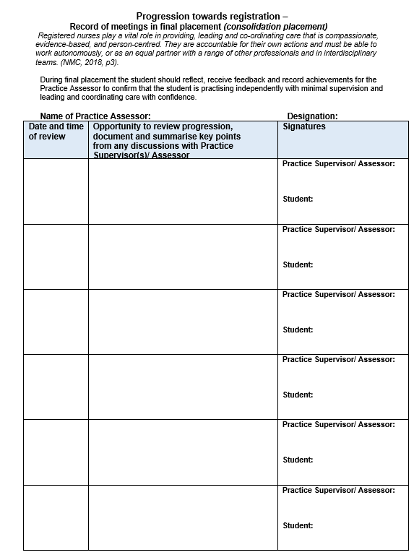

Action Plan
There are Action Plans available within each Part. An Action Plan should be completed if there is cause for concern in relation to the student’s performance. For example, failure to achieve components of assessment such as Professional Values.  If a student requires an Action Plan, the Practice Assessor should liaise with the Academic Assessor and is responsible for reviewing progress and ensuring support and learning is available. Depending on the AEI and the practice placement’s policy, the Practice Assessor may have to inform the nominated person on placement.  FAQs  Q: What timescale should be used for the student to achieve the Action Plan?  A: This will depend on the area of concern and the frequency of learning opportunities available within the length of the placement. The student has to be able to attend and engage in learning in order to achieve the action plan.  Q: How much support and learning should be provided?  A: This will depend on the Part that the student is undertaking and the complexity of the area of concern. The student has to be able to demonstrate competence or professionalism relevant to the stage of the programme.  Q: What happens if the student does not achieve the objectives within the Action Plan by the stated review date?  A: The Practice Assessor will need to document their decision regarding whether the student has failed the placement and communicate the outcome with the Academic Assessor. | 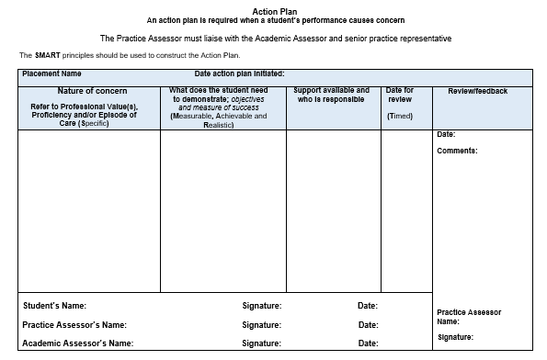

Ongoing Achievement Record (OAR)
The Ongoing Achievement Record (OAR) summarises the student’s achievements in each placement and with the Practice Assessment Document (PAD) provides a comprehensive record of professional development and performance in practice.  The Practice Assessor completes the summary page at the end of each placement and at the end of each Part completes the progression statement.  The Academic Assessor confirms the completion of each placement, adds comments and at the end of each Part completes the progression statement.  Listed in the OAR - Achievement of Parts 2 and 3 proficiencies: To support the student progressing effectively through the programme and in utilising the valuable opportunities available across a range of  placements certain proficiencies have been identified that can be met in Part 2 OR Part 3. These are listed in Part 2, Part 3 and in the OAR. The Practice Assessor needs to complete this at the end of Part 2 and Part  3. Any proficiencies not met in Part 2 are then identified as the student needing to achieve these in Part 3.  FAQs  Q: Should the Academic Assessor be present when the OAR is completed?  A: The Academic Assessor liaises with the Practice Assessor to confirm progression at the end of each Part in the PAD and OAR. Communication must be scheduled for this to occur and may be face to face or though other communication methods. If the student has not achieved assessment in order to progress, the Practice Assessor and the Academic Assessor will liaise and complete an Action Plan. | 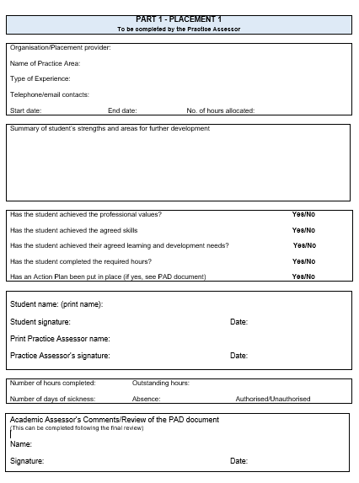

How does the Practice Assessment Document relate to different fields of practice?

The Future Nurse: Standards of proficiency for registered nurses (NMC 2018) form the content of all the assessment items of the PAD.

The NMC standards specify the knowledge and skills that Registered Nurses must demonstrate when caring for people of all ages and across all care settings. The role of the nurse in the 21st century is to provide care for people who have complex mental, physical, cognitive and behavioural care needs across a range of settings including people’s own home, in the community or hospital or any health and social care setting.

The outcome statements within the standards of proficiency apply across all fields of Nursing practice (adult, children, learning disabilities and mental health) and all care settings as Registered Nurses must be able to meet the person-centred, holistic needs of the people they encounter in their practice who may be at any stage of their life and who may have a range of mental, physical, cognitive or behavioural health challenges.

The annexes within the standards of proficiency also apply across all fields and demonstrate what Registered Nurses should be able to demonstrate at the point of registration. Annex A specifies the communication and relationship management skills required and Annex B specifies the nursing procedures that Registered Nurses must demonstrate safely. The level of expertise and knowledge required for both annexes will vary dependent on the chosen field(s) of practice. Registered Nurses must be able to demonstrate the ability to undertake these skills and procedures at an appropriate level for their intended field(s) of practice.

Assessment items and guidance for fields:

- Professional Values – all professional values are of relevance to all fields equally and are assessed using the same approaches to the demonstration of these values in practice.

- Proficiencies, including skills and procedures – these should be assessed within the field of practice that the student is undertaking. However, when considering the person’s age and a range of mental, physical, cognitive and behavioural health challenges, the student can learn and be assessed across different health and social care settings. Simulation in practice can also be used as a strategy for learning and assessment.

Examples Part 1: ‘Demonstrates an understanding of the importance of therapeutic relationships in providing an appropriate level of care to
support people with mental health, behavioural, cognitive and learning challenges.’ Adult Nursing – a person with dementia receiving nursing care in a surgical ward Mental Health Nursing – a person with anxiety receiving nursing care in their own home
Learning Disabilities Nursing – a person with moderate learning disabilities and depression receiving nursing care in an in-patient service Children’s Nursing – a child or young person who is responding to the pain that they are experiencing from a surgical procedure in a day surgery unit

Examples Part 1: ‘7. Takes appropriate action in responding promptly to signs of deterioration or distress considering mental, physical, cognitive
and behavioural health’
Adult Nursing – a person with anxiety and depression who has self-harmed receiving nursing care in an in-patient ward (e.g. mental health placement)
Mental Health Nursing – a person with psychosis who is threatening physical harm to others and has hand injuries receiving nursing care in their own home
Learning Disabilities Nursing – a person with severe learning disabilities who is having a tonic clonic seizure receiving nursing care in a specialist day service
Children’s Nursing – a child or young person who has self-harmed receiving nursing care in an in-patient service

Examples Part 1: ‘15. Selects and uses appropriate continence and feminine hygiene products, for example pads, sheaths and appliances as
appropriate.’’
Adult Nursing – a person who has undergone medical procedures requiring the person to remain prone receiving nursing care Mental Health Nursing – an older adult with depression receiving nursing care in an in-patient ward
Learning Disabilities Nursing – a person with profound learning disabilities who is fully dependent for all needs to be met receiving nursing care by a community nurse
Children’s Nursing – a young person who is recovering from bi-lateral fractured femurs receiving nursing care in a ward

Examples Part 2: ‘3. Recognise people at risk of self-harm and/or suicidal ideation and demonstrate knowledge and skills required to support person-centred evidence-based practice using appropriate risk assessment tools as needed’
Adult Nursing – a person with wounds to face and hands and suspected fractured arm who has taken alcohol and/or drugs receiving nursing care in A&E
Mental Health Nursing – a person with psychosis who is responding to voices to kill themselves receiving nursing care in psychiatric intensive care
Learning Disabilities Nursing – a person with severe learning disabilities who hits themselves on the head/face to gain staff response receiving nursing care by a community nurse
Children’s Nursing – a child or young person who is repeatedly attempting to pull out their PEG button receiving nursing care in their own home

Examples Part 2: ‘27. Manage and monitor blood component transfusions in line with local policy and evidence based practice’
Adult Nursing – a person with severe stab wounds post-surgery receiving nursing care in intensive care Mental Health Nursing – a person who is older with anaemia who is receiving nursing care in a medical ward Learning Disabilities Nursing – a person with cancer receiving nursing care in an outpatient’s oncology service
Children’s Nursing –a child or young person who has sickle cell disease who is receiving nursing care in a ward

Examples Part 2: ’30. Demonstrates awareness of strategies that develop resilience in themselves and others and applies these in practice e.g. solution focused therapies or talking therapies’
Adult Nursing – a person with dementia who is spending a lot of time looking for their baby receiving nursing care in a nursing home Mental Health Nursing – a person with depression who has had abdominal surgery who is very upset receiving nursing care
Learning Disabilities Nursing – a person with long term anxiety who has stopped taking medication receiving nursing care in their own home Children’s Nursing – a young person who is a single mother who is extremely distressed as her first baby who is four weeks old has severe vomiting requiring medical intervention receiving nursing care

Examples Part 3: ‘9. Is able to support people distressed by hearing voices or experiencing distressing thoughts or perceptions’
Adult Nursing – a person with psychosis who is actively responding to voices they are hearing by shouting at the television receiving nursing care in an in-patient service
Mental Health Nursing – a person who is a young person who has anorexia and is distressed about their weight gain receiving nursing care in an in-patient service
Learning Disabilities Nursing – a person with mild learning disabilities who has depression who is upset about their lack of family and friendships receiving nursing care by a community nurse
Children’s Nursing – a young person who has ADHD and anxiety and is experiencing a panic attack receiving nursing care by a community nurse

Examples Part 3: ‘12. Manages the care of people who are receiving IV fluids and accurately records fluid intake and output, demonstrating
understanding of potential complications’
Adult Nursing – a person who is older and admitted due to dehydration receiving nursing care
Mental Health Nursing – a person who has contracted e-coli receiving nursing care on an inpatient ward Learning Disabilities Nursing – a person with unstable diabetes receiving nursing care on an inpatient ward Children’s Nursing – a person who is young person who has cancer and is receiving nursing care

Examples Part 3: ‘26. Evaluates the quality of peoples’ experience of complex care, maintains optimal independence and avoids unnecessary
interventions and disruptions to their lifestyle’
Adult Nursing – a person with diabetes and cancer receiving nursing care in a joint out-patient appointment to establish the best approach to least invasive treatment
Mental Health Nursing – a person with long-term anxiety and depression receiving nursing care in a group therapy model focussing on solution
–focused therapy
Learning Disabilities Nursing – a person with mild learning disabilities who lives alone and has epilepsy, depression and hypertension due to obesity receiving nursing care in a multi-agency approach to ensuring on-going support and intervention
Children’s Nursing – a child or young person who has a life-limiting condition that is deteriorating and is receiving nursing care in a hospice

- Episode of Care – these must be undertaken in the field of practice which the student is undertaking. These episodes of care relate to; a person receiving care, a group of people receiving care, people with complex needs receiving care, junior learners in practice and a group/caseload of people with complex needs receiving care. The student and Practice Assessor will discuss the episodes of care and agree what the assessment will consist of and when this should be undertaken.

- Medicines Management – these assessments can be carried out in any setting where there is regular dispensing and administrating of medicines to individuals or groups, either in the field of practice the student is undertaking or in any other experiential placement. The level of complexity is enhanced each year. The student and Practice Assessor will agree when this should be undertaken.

